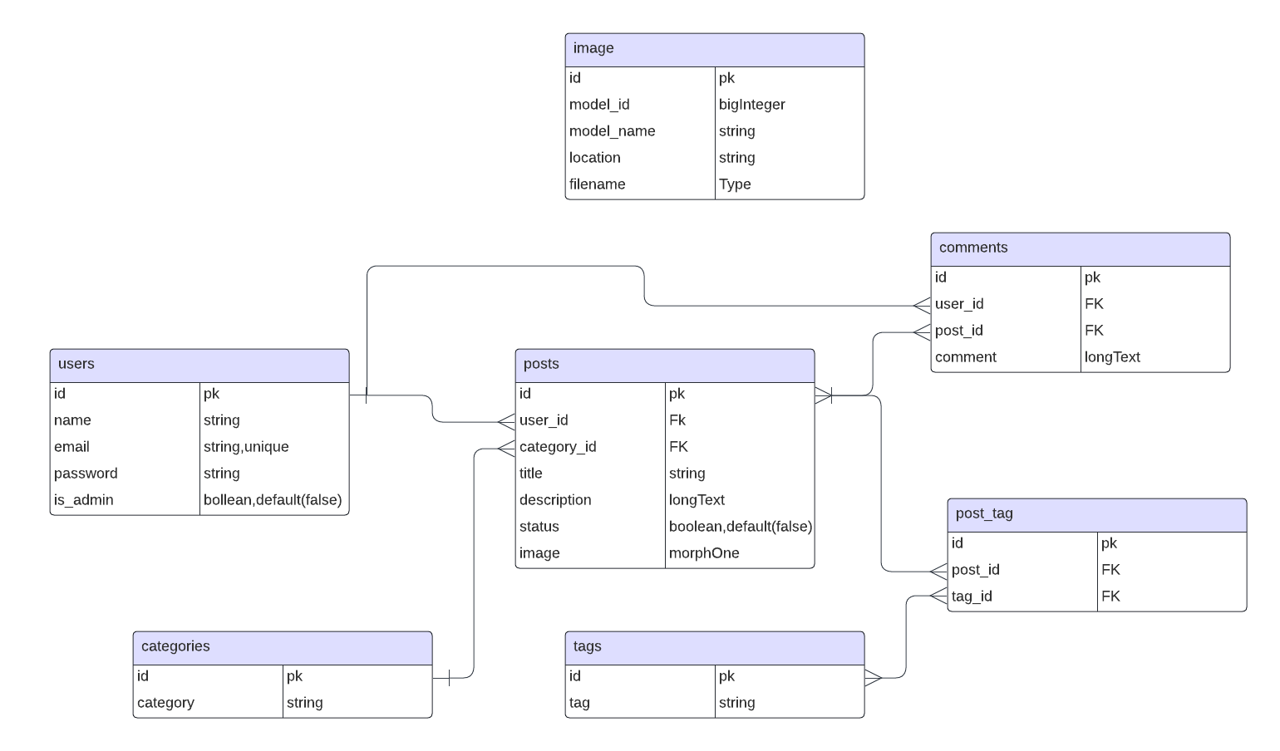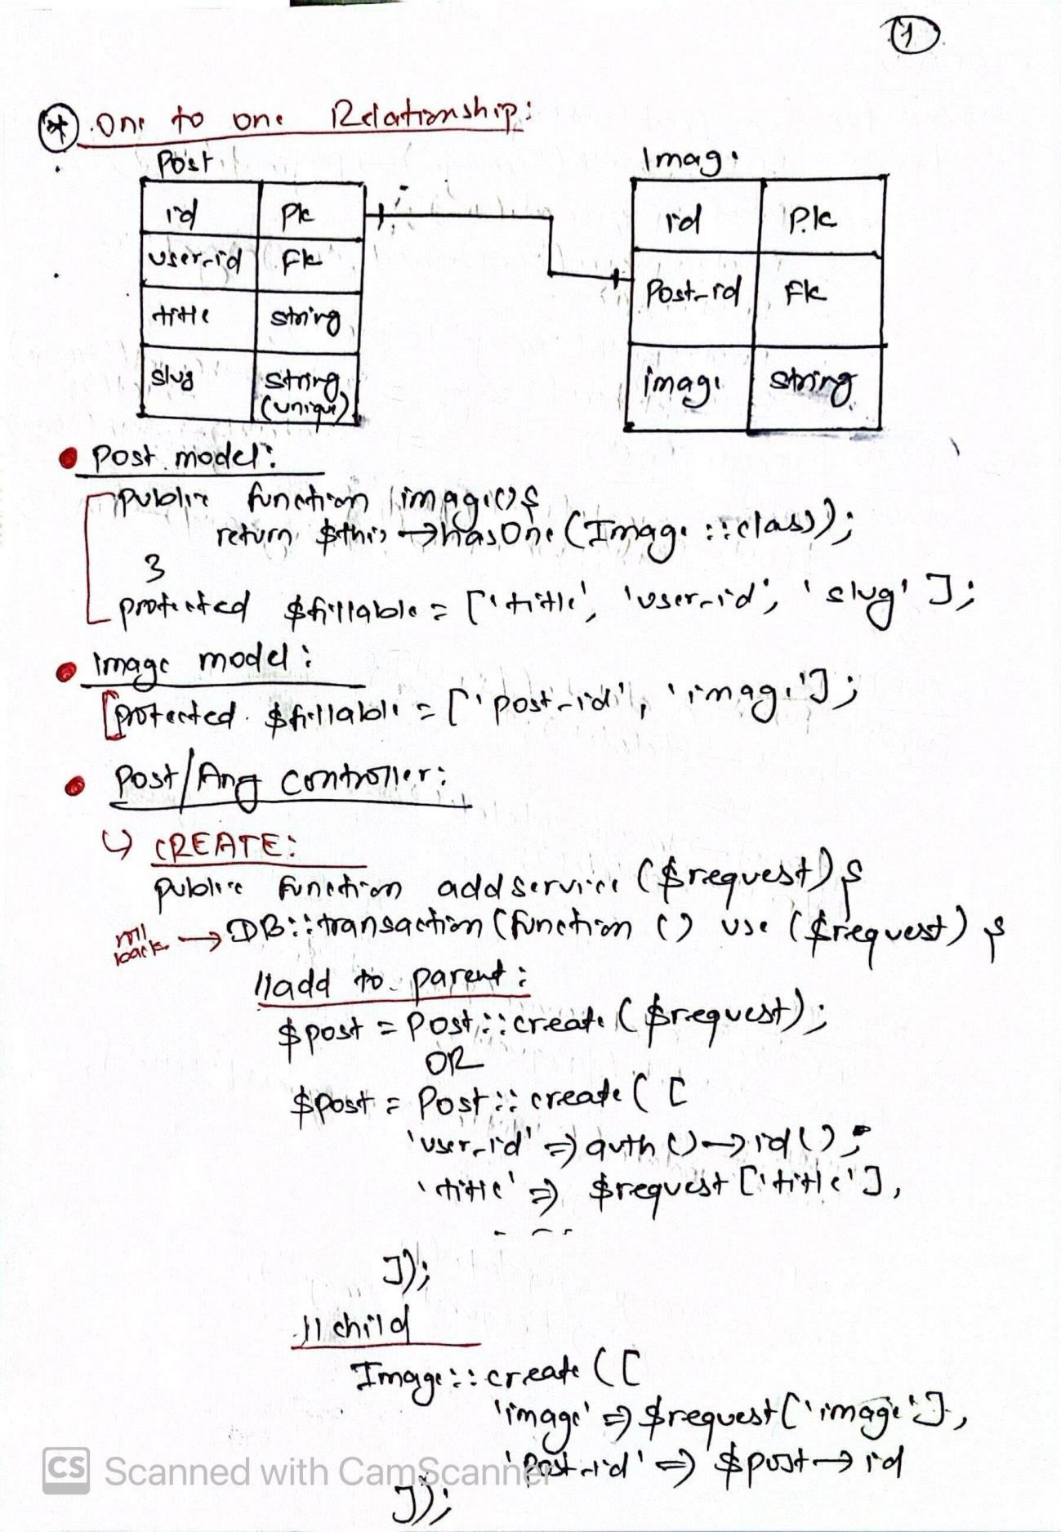

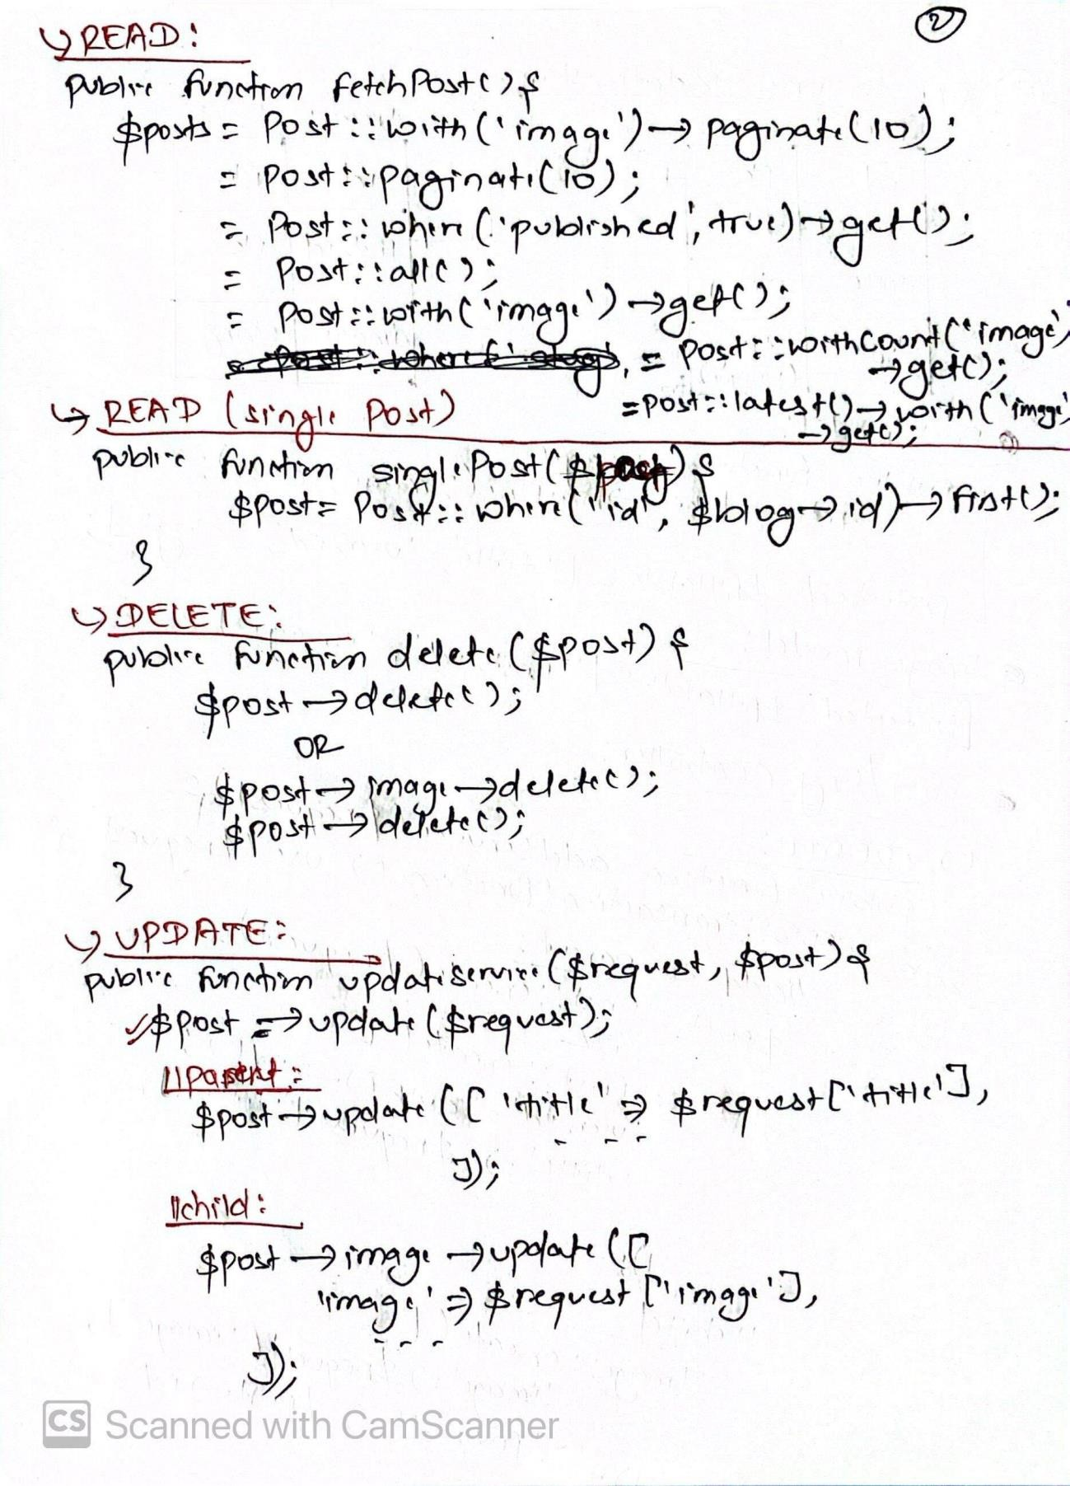

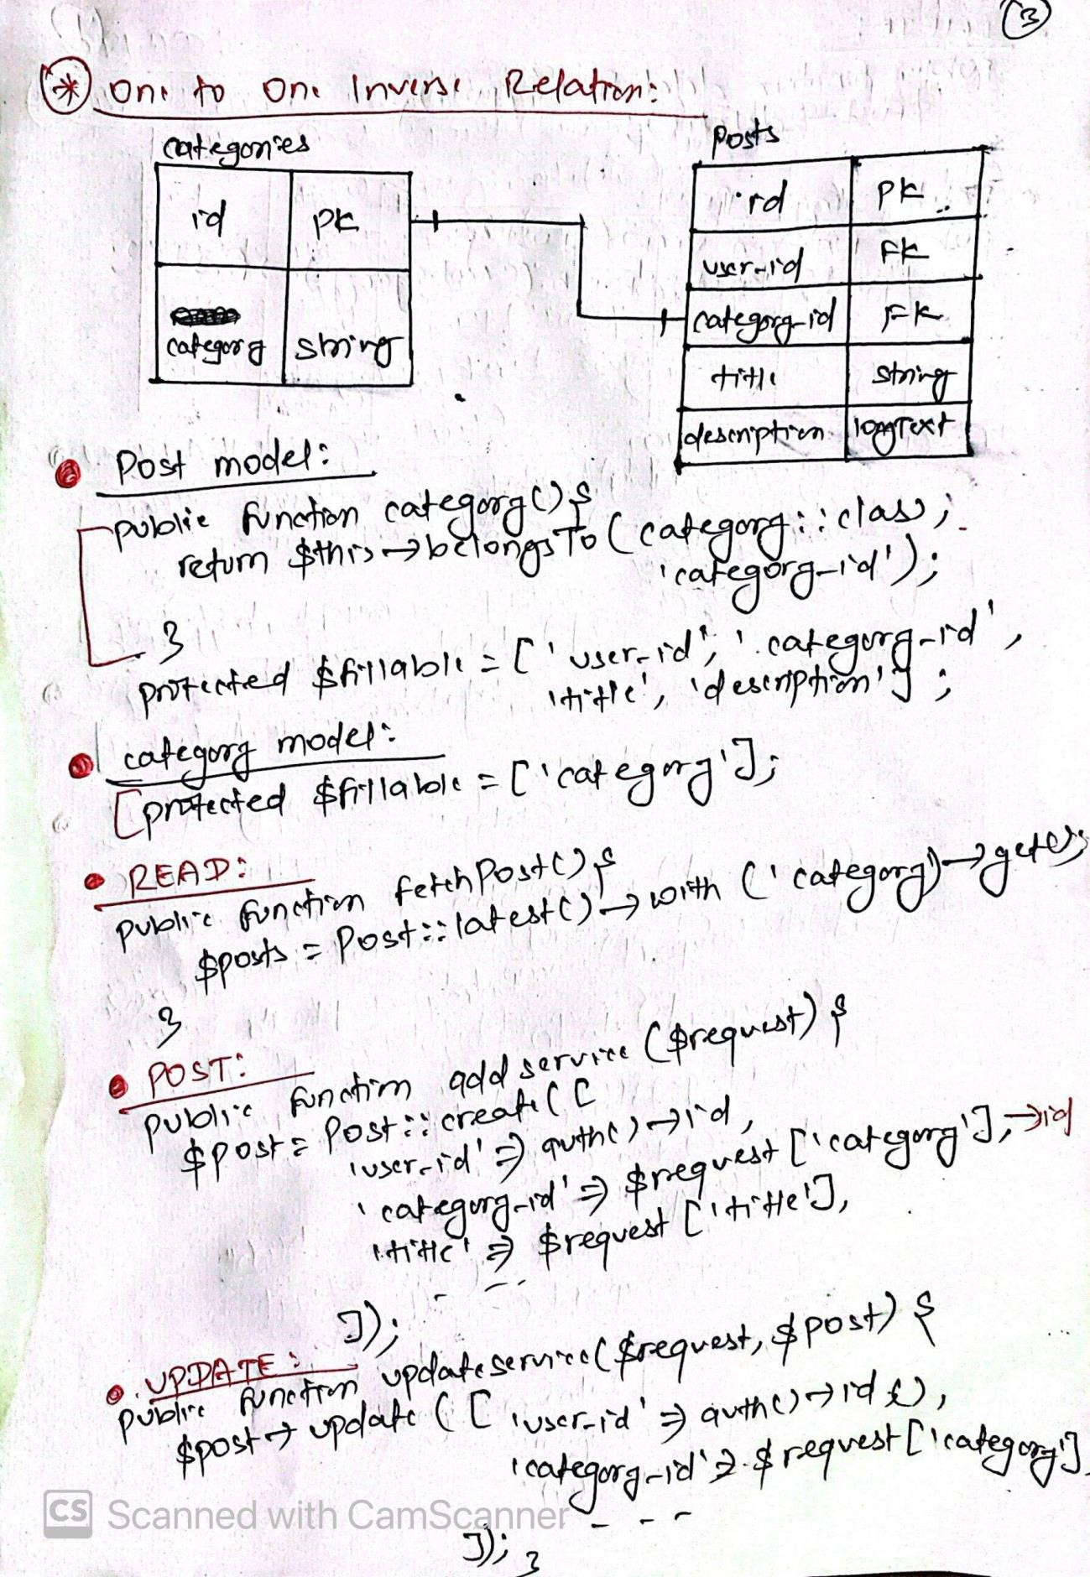

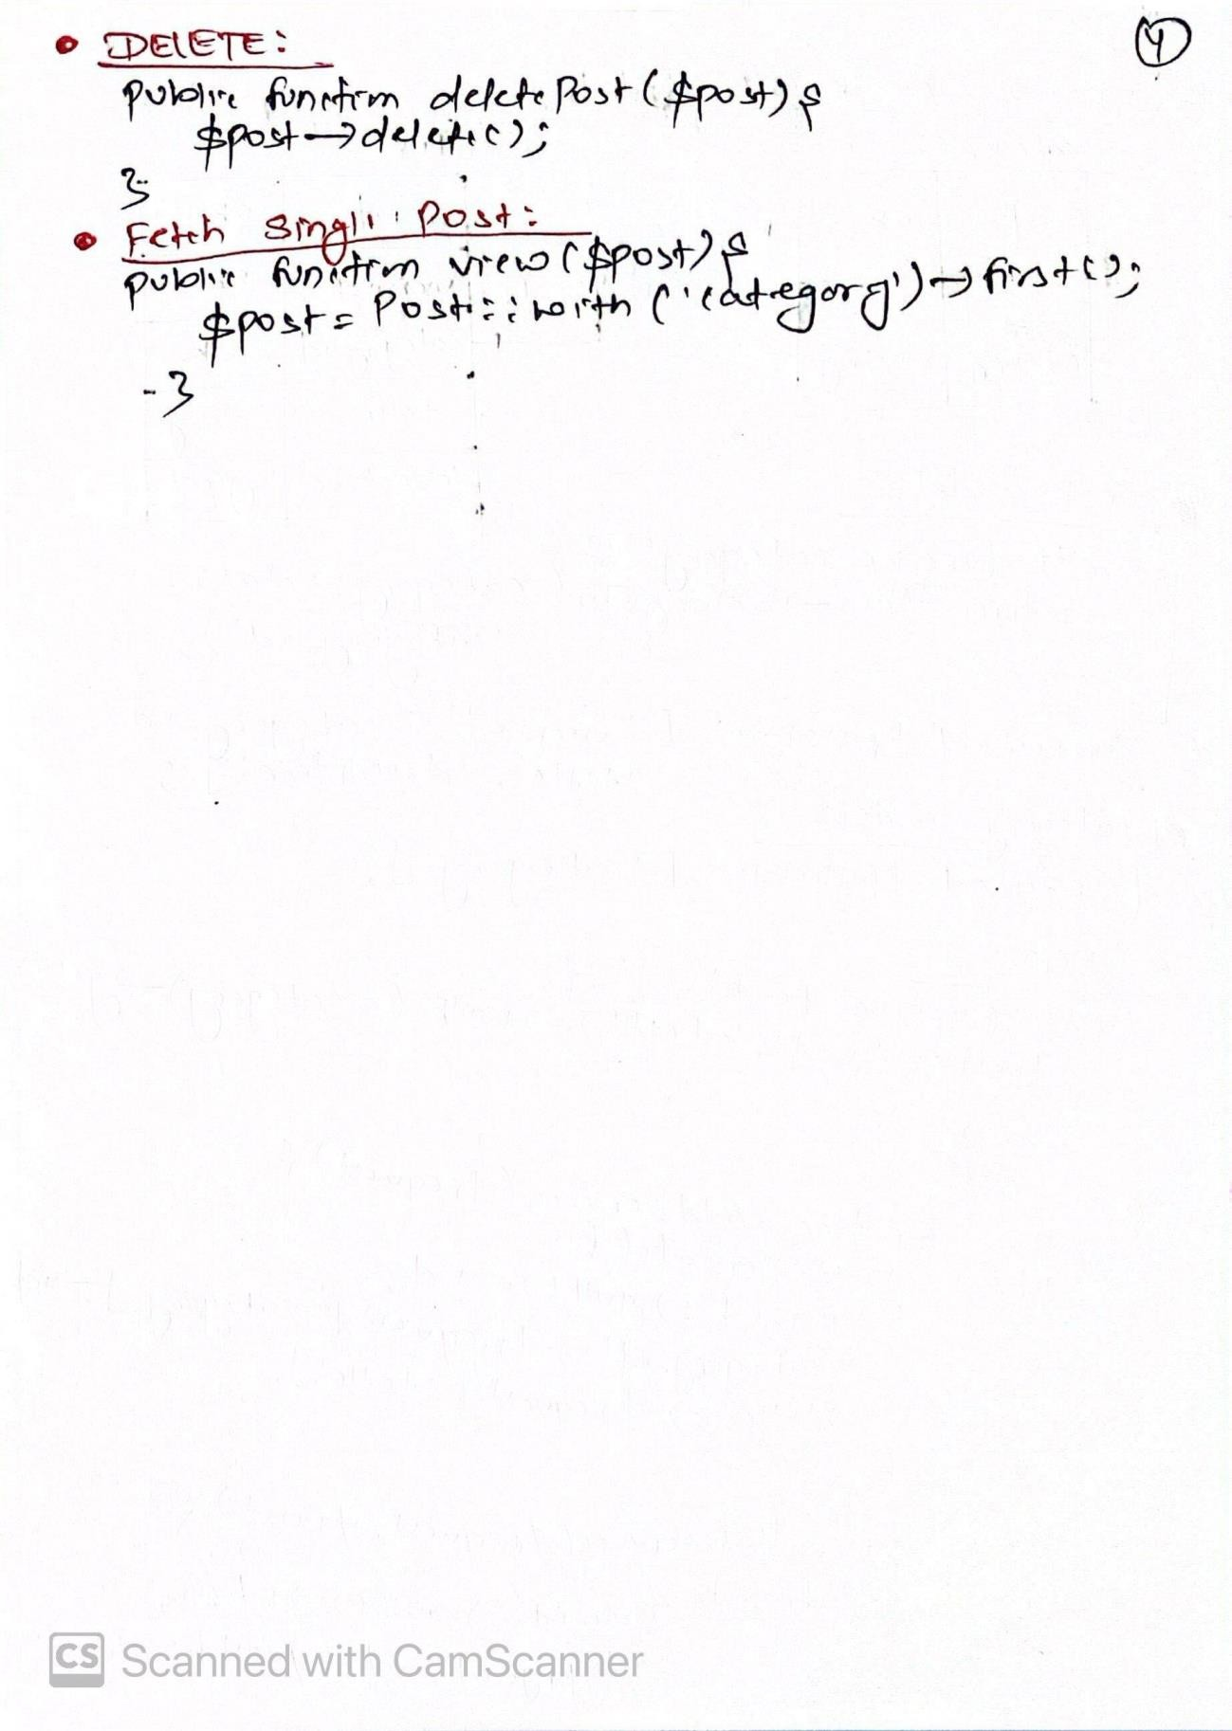

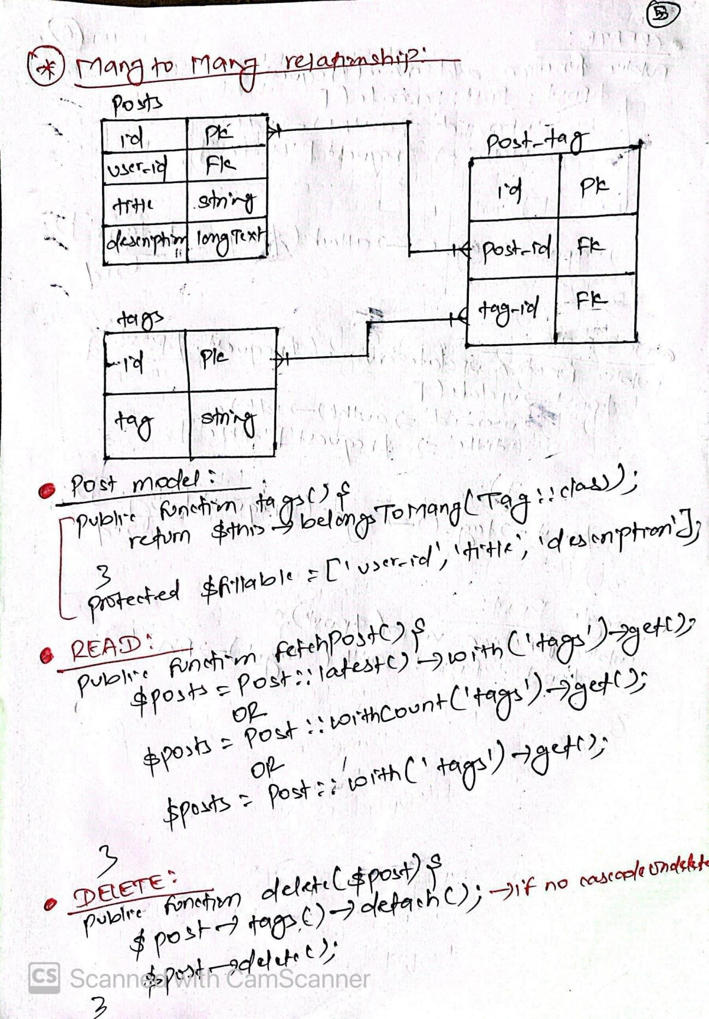

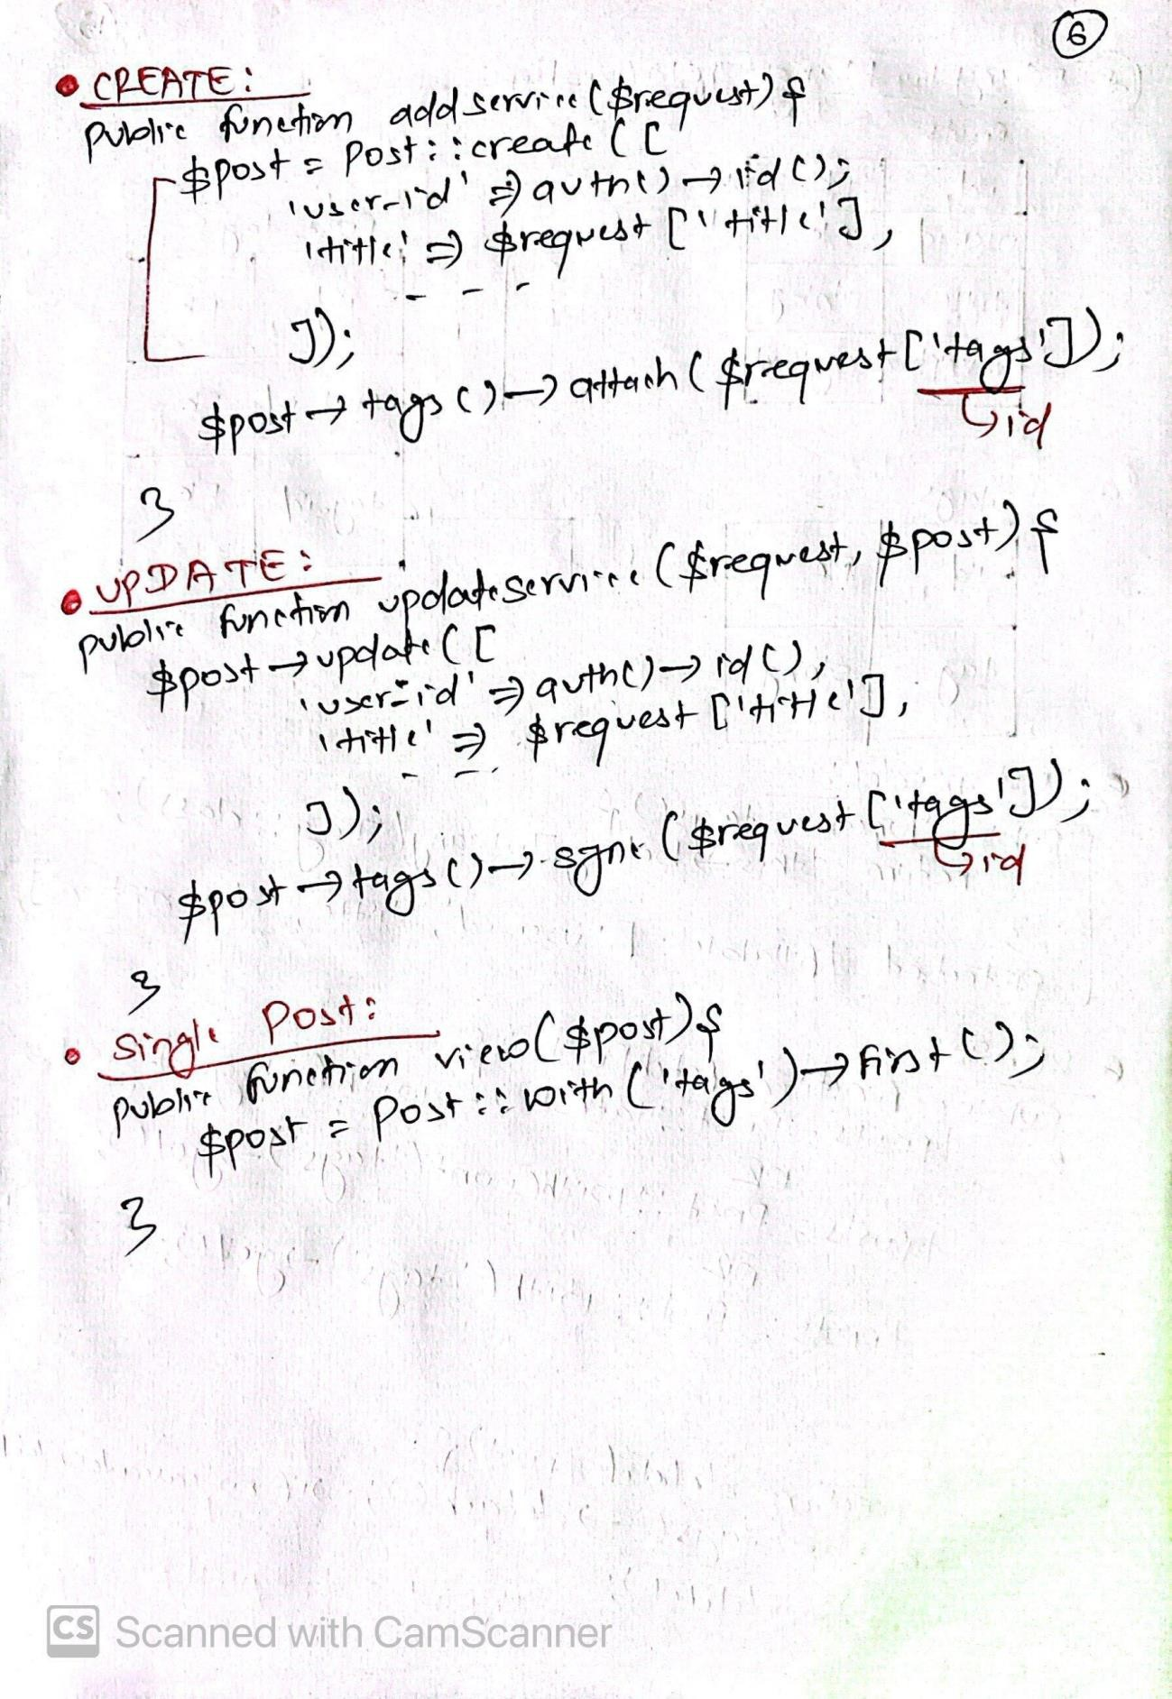

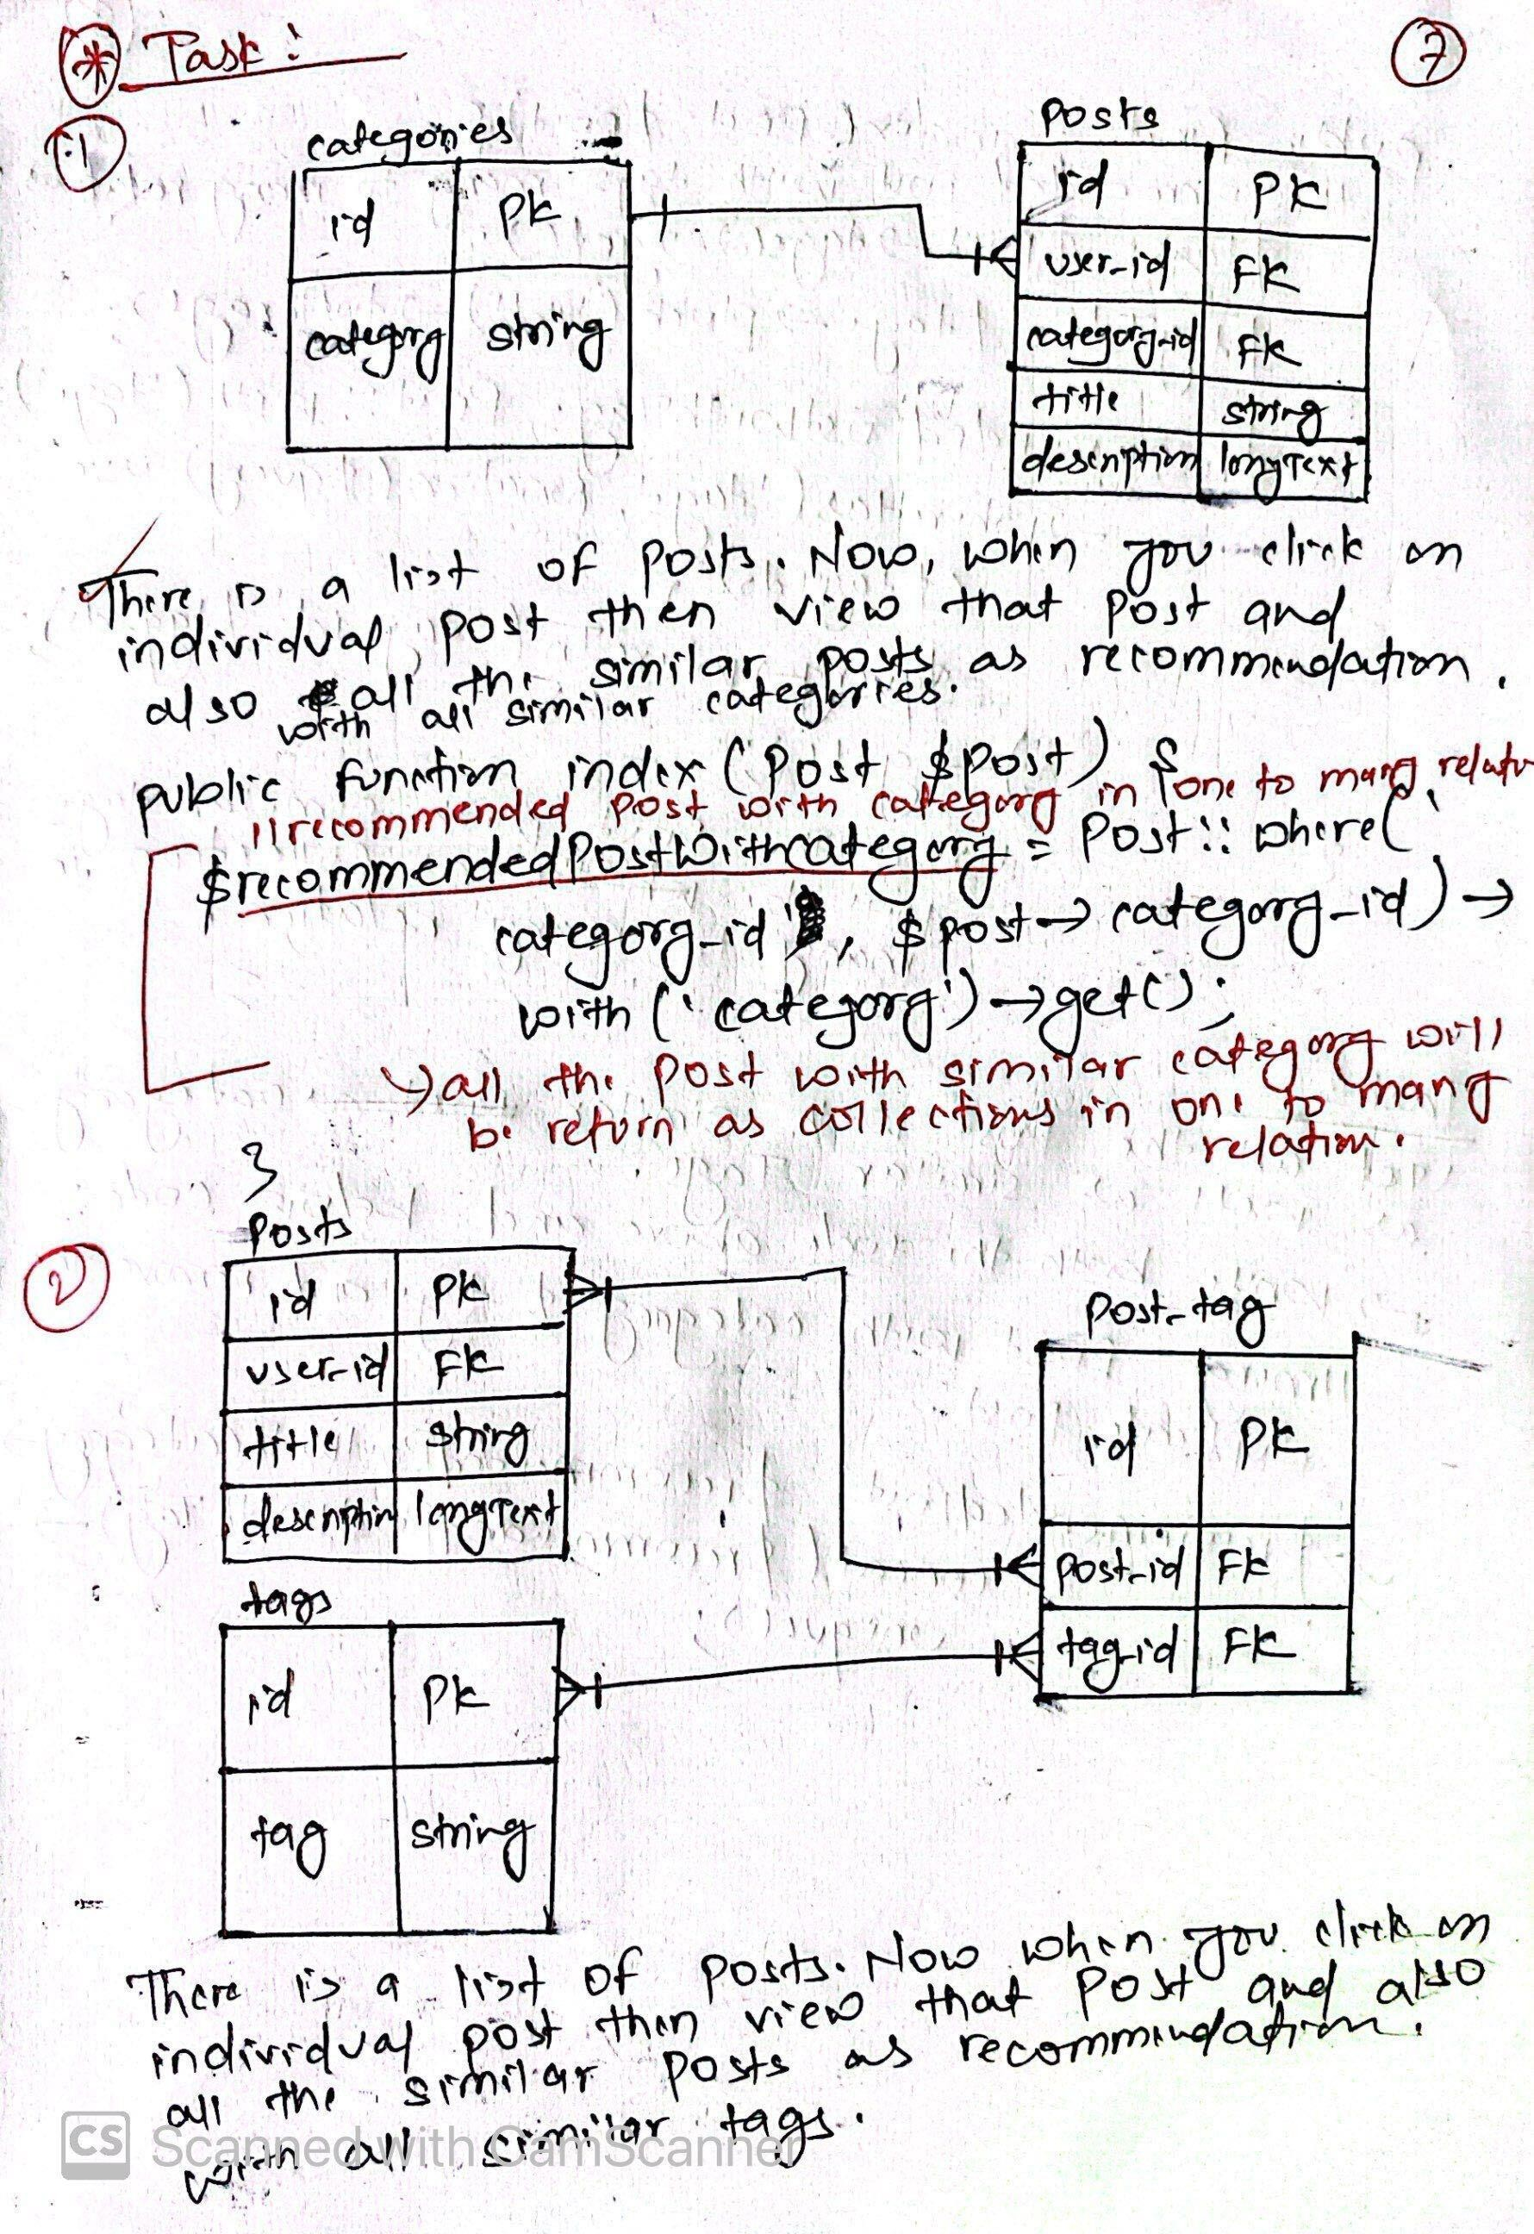

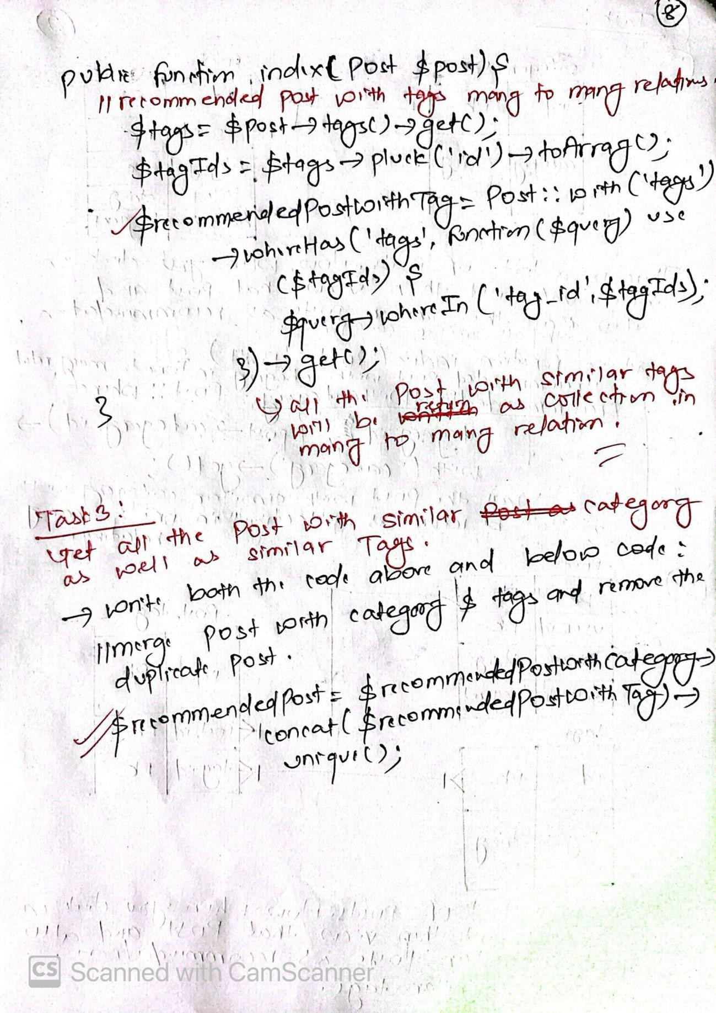

# Fetch all the data with Filter:

Example of One to One Relationship:

<?php

namespace App\Service; use App\Models\Blog;

use App\Models\BlogInfo;

use Illuminate\Support\Facades\Storage;

// one to one relation class BlogService

{

// =============POST============

public function addService($request)

{

// store single image in local storage folder if (isset($request['image'])) {

$timestamp = now()->timestamp;

$originalName = $request['image']->getClientOriginalName();

$imageName = $timestamp . '-' . $originalName;

$request['image']->storeAs('public/images/blogs', $imageName);

// update the image name in the $request array

$request['image'] = $imageName;

};

// store in database table

// Blog::create($request);

// =====one to one relation======

// store in parent table

$blog = Blog::create([

'title' => $request['title'], 'slug' => $request['slug'],

]);

// store in child table BlogInfo::create([

'image' => $request['image'], 'description' => $request['description'], 'blog_id' => $blog->id,

]);

}

// ========GET(Read all)================

public function fetchBlogs()

{

// $blogs=Blog::paginate(10); //Paginate with 10 records per page

// $blogs=Blog::where('published',true)->get(); //where published=true

// $blogs=Blog::select('SELECT * FROM blogs'); //raw sql

// $blogs=Blog::all(); //fetch all the records

$blogs = Blog::with('blog_info')->get(); //fetch all data with one to one relation

// $blogs=Blog::with('blog_info')->paginate(10); // fetch data relationship with one to one

return $blogs;

}

// =========DELETE==========

public function delete($blog)

{

// delete image from local storage

if (isset($blog->blog_info->image)) { Storage::delete('public/images/blogs/' . $blog->blog_info->image);

}

// if cascade on delete not used:

// $blog->blog_info->delete(); //delete child record

// $blog->delete(); //delete parent record

// if cascade on delete used:

$blog->delete();

}

// ========FETCH(Single Blog)====== public function singleBlog($blog)

{

// $blogs=Blog::where('slug',$blog->slug)->first(); return $blog;

}

// =======UPDATE(PUT)==============

public function updateService($request, $blog)

{

// $blog->update($request); //update data in db if no image & relation

// Check if a new image is uploaded if (isset($request['image'])) {

// Delete the old image from storage folder Storage::delete('public/images/blogs/' . $blog->blog_info->image);

// Store the new image

$timestamp = now()->timestamp;

$originalName = $request['image']->getClientOriginalName();

$imageName = $timestamp . '-' . $originalName;

$request['image']->storeAs('public/images/blogs', $imageName);

// Update the image name in the $request array

$request['image'] = $imageName;

} else {

$request['image'] = $blog->blog_info->image;

}

// Update in parent table

$blog->update([

'title' => $request['title'], 'slug' => $request['slug'],

]);

// Update in child table

$blog->blog_info->update([ 'image' => $request['image'],

'description' => $request['description'],

]);

}

}

# Example of One to Many Relationship:

<?php

namespace App\Service;

use App\Models\Blog;

use App\Models\BlogInfo;

use Illuminate\Support\Facades\Storage;

// one to many relation class BlogService

{

// =========POST======

public function addService($request)

{

// Initialize an empty array to store image names

$imageNames = [];

// Store multiple images in local storage folder if (isset($request['image'])) {

foreach ($request['image'] as $key => $image) {

$timestamp = now()->timestamp;

$originalName = $image->getClientOriginalName();

$imageName = $timestamp . '-' . $originalName;

$image->storeAs('public/images/blogs', $imageName);

// Store the image name in the array

$imageNames[] = $imageName;

}

}

// Create the Blog entry

$blog = Blog::create([

'title' => $request['title'], 'slug' => $request['slug'],

'description' => $request['description'],

]);

// Create BlogInfo entries associated with the Blog foreach ($imageNames as $imageName) {

BlogInfo::create([

'image' => $imageName, 'blog_id' => $blog->id,

]);

}

}

// ========GET(Read all)================

public function fetchBlogs()

{

// $blogs=Blog::paginate(10); //Paginate with 10 records per page

// $blogs=Blog::where('published',true)->get(); //where published=true

// $blogs=Blog::select('SELECT * FROM blogs'); //raw sql

// $blogs=Blog::all(); //fetch all the records

$blogs = Blog::with('blog_info')->get(); //fetch all data with one to one relation

// $blogs=Blog::with('blog_info')->paginate(10); // fetch data relationship with one to one

return $blogs;

}

// =========DELETE==========

public function delete($blog)

{

// delete image from local storage if (isset($blog->blog_info)) {

foreach ($blog->blog_info as $key => $image) { Storage::delete('public/images/blogs/' . $image->image);

}

}

// if cascade on delete not used:

// $blog->blog_info->delete(); //delete child record

// $blog->delete(); //delete parent record

// if cascade on delete used:

$blog->delete();

}

// ========FETCH(Single Blog)====== public function singleBlog($blog)

{

// $blogs=Blog::where('slug',$blog->slug)->first(); return $blog;

}

// =======UPDATE(PUT)==============

public function updateService($request, $blog)

{

// Check if new images are uploaded if (isset($request['image'])) {

// Delete old images from storage folder and database foreach ($blog->blog_info as $oldImage) {

// Delete from local storage Storage::delete('public/images/blogs/' . $oldImage->image);

// Delete from database

$oldImage->delete();

}

// Store the new images

foreach ($request['image'] as $key => $image) {

$timestamp = now()->timestamp;

$originalName = $image->getClientOriginalName();

$imageName = $timestamp . '-' . $originalName;

$image->storeAs('public/images/blogs', $imageName);

// Update in child table

$blog->blog_info()->create([ 'image' => $imageName,

]);

}

// Update in parent table

$blog->update([

'title' => $request['title'], 'slug' => $request['slug'],

'description' => $request['description'],

]);

} else {

// If no new images, update only the parent table

$blog->update([

'title' => $request['title'], 'slug' => $request['slug'],

'description' => $request['description'],

]);

}

}

}

# Many to Many Relationship:

// ===========POST(Add)=================

public function addService($request)

{

DB::transaction(function () use ($request) { //->roll back if not inserted in relationship table

// adding data in parent table

$post = Post::create([ 'user_id' => auth()->id(),

'caregory_id' => $request['category'], 'title' => $request['title'], 'description' => $request['description'], 'status' => $request['status'],

]);

});

}

// add data with many to many relation

$post->tags()->attach($request['tags']);

// =====================================

// ==============GET All==================

public function fetchPost()

{

$posts = Post::latest()->get(); return $posts;

}

// =======================================

// =========fetch single post=========== public function view($post)

{

$singlePost = Post::find($post->id); return $singlePost;

}

// =====================================

// ===========UPDATE POST==============

public function updateService($request, $post)

{

// updating data in parent table

$post->update([

'user_id' => auth()->id(), 'caregory_id' => $request['category'],

'title' => $request['title'], 'description' => $request['description'], 'status' => $request['status'],

]);

// updating data with many to many relation

$post->tags()->sync($request['tags']);

}

// ====================================

// =============DELETE=================

public function deletePost($post)

{

//if not used cascadeOnDelete() then you should detach from many to many relation else you can directly use delete only

$post->tags()->detach();

$post->delete();

}

// ====================================

# C:\Users\yubra\Downloads\image (2).pngC:\Users\yubra\Downloads\image (2).pngRouting:

CRUD With AJAX:

## Frontend(index.blade.php):

<script>

$(document).ready(function() {

// =====setup csrf token======

$.ajaxSetup({

headers: {

'X-CSRF-TOKEN': $('meta[name="csrf-token"]').attr('content')

}

});

// =====Reset form============

$('#addButton').click(function() {

$('#ajaxForm')[0].reset();

$('#categoryError').html('');

$('#slugError').html('');

});

// ========ADDING DATA TO DB(POST)=============//

var createFormData = $('#ajaxForm')[0];

$('#saveBtn').click(function() {

// setting empty text on error message

$('#categoryError').html('');

$('#slugError').html('');

// getting form data

var formData = new FormData(createFormData);

// console.log(formData);

$.ajax({

url: "{{ route('category.store') }}", method: 'POST',

processData: false, contentType: false, data: formData,

success: function(response) { table.draw();

$('#addCategory').modal('hide');

$('#ajaxForm')[0].reset(); toastify().success(response.success);

},

error: function(error) {

let errorMessage = error.responseJSON.errors; if (errorMessage) {

if (errorMessage.name) {

$('#categoryError').html(errorMessage.name[0]);

}

if (errorMessage.slug) {

$('#slugError').html(errorMessage.slug[0]);

}

} else {

toastify().error('Something went wrong');

}

});

}

});

// ======================================================//

// ===========READ DATA FROM DB(READ)====================//

var table = $('#category-table').DataTable({ "processing": true,

"serverSide": true, "deferRender": true, "ordering": false, searchDelay: 3000, "ajax": {

url: "{{ route('category.index') }}", type: 'GET',

dataType: 'JSON'

},

"columns": [{

data: 'DT_RowIndex', name: 'DT_RowIndex', searchable: false

},

{

data: 'name',

name: 'name',

},

{

data: 'slug', name: 'slug'

},

{

data: 'action', name: 'action', orderable: false,

searchable: false

},

],

"lengthMenu": [

[10, 20, 50, -1],

[10, 20, 50, "All"]

});

],

"pagingType": "simple_numbers"

// ====================================================//

// ================DELETE CATEGORY===================//

$('body').on('click', '.delButton', function() { let slug = $(this).data('slug');

if (confirm('Are you sure you want to delete it')) {

$.ajax({

url: '{{ url('admin/category/', '') }}' + '/' + slug, method: 'DELETE',

success: function(response) {

// refresh the table after delete table.draw();

// display the delete success message toastify().success(response.success);

},

error: function(error) { console.log(error);

}

});

}

});

// ==========================================//

// =====Fill Current Data to form while UPDATION========// let slug = '';

$('body').on('click', '.editButton', function() {

// get form slug

slug = $(this).data('slug');

$.ajax({

url: '{{ url('admin/category', '') }}' + '/' + slug +'/edit', method: 'GET',

success: function(response) {

$('#editCategory').modal('show');

$('#updateCategory').val(response.name);

$('#updateSlug').val(response.slug);

$('#category_slug').val(response.slug);

},

error: function(error) { console.log(error);

}

})

});

// =============================================================//

// =====UPDATING CATEGORY TO DB(UPDATE/PUT)===========//

var updateFormData = $('#ajaxFormUpdate')[0];

$('#updateBtn').click(function() {

// setting empty text on error message

$('#categoryUpdateError').html('');

$('#slugUpdateError').html('');

// getting form data

var formUpdateData = new FormData(updateFormData);

$.ajax({

url: '{{ url('admin/category/', '') }}' + '/' + slug, method: 'POST',

processData: false, contentType: false, data: formUpdateData,

success: function(response) {

// reload the latest row after added table.draw();

// hide model if success

$('#editCategory').modal('hide');

// clear form after successfully submitting

$('#ajaxFormUpdate')[0].reset();

// display success message if form submitted toastify().success(response.success);

},

[0]);

error: function(error) {

let errorMessage = error.responseJSON.errors;

// displaying error message if (errorMessage) {

if (errorMessage.title) {

$('#categoryUpdateError').html(errorMessage.title

}

if (errorMessage.slug) {

$('#slugUpdateError').html(errorMessage.slug[0]);

}

} else {

toastify().error('Something went wrong!');

}

}

});

});

//

======================================================================//

});

</script>

## CategoryController:

private $categoryService;

public function construct()

{

$this->categoryService = new CategoryService();

}

public function index(Request $request)

{

try {

if ($request->ajax()) {

$categories = $this->categoryService->fetchCategory(); return DataTables::of($categories)

->addIndexColumn()

->addColumn('action', function ($row) {

return '<a href="javascript:void(0)" class="btn btn-info editButton" data-slug="' . $row->slug . '">Edit</a>

<a href="javascript:void(0)" class="btn btn-danger delButton" data-slug="' . $row->slug . '">Delete</a>';

})

->rawColumns(['action'])

->make(true);

}

return view('admin.category.index');

} catch (\Throwable $th) {

return back()->with('error', $th->getMessage());

}

}

public function store(CategoryRequest $request)

{

try {

$this->categoryService->addService($request->validated()); return response()->json([

'success' => 'Category added successfully'

]);

} catch (\Throwable $th) {

return back()->with('error', $th->getMessage());

// return response()->json(['error' =>'Something went wrong'],500);

}

}

public function edit(string $slug)

{

try {

$category = $this->categoryService->fetchSingleCategory($slug); if (!$category) {

abort(404);

}

return $category;

} catch (\Throwable $th) {

return back()->with('error', $th->getMessage());

}

}

public function update(Request $request, string $slug)

{

try {

$category = Category::where('slug', $request->category_slug)-

>first();

if (!$category) { abort(404);

}

$this->categoryService->updateCategory($request->except('_method', 'category_slug'), $category);

return response()->json([

'success' => 'Category Updated Successfully'

], 201);

} catch (\Throwable $th) {

return back()->with('error', $th->getMessage());

}

}

public function destroy(string $slug)

{

try {

$category = Category::where('slug', $slug)->first(); if (!$category) {

abort(404);

}

$this->categoryService->delete($category); return response()->json([

'success' => 'Category Deleted Successfully'

], 201);

} catch (\Throwable $th) {

return back()->with('error', $th->getMessage());

}

}

Search Blogs without page load using AJAX:

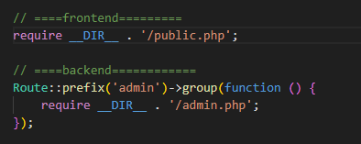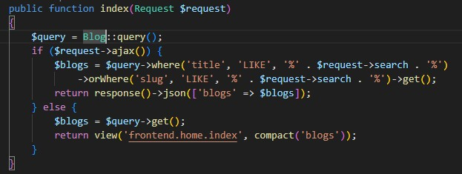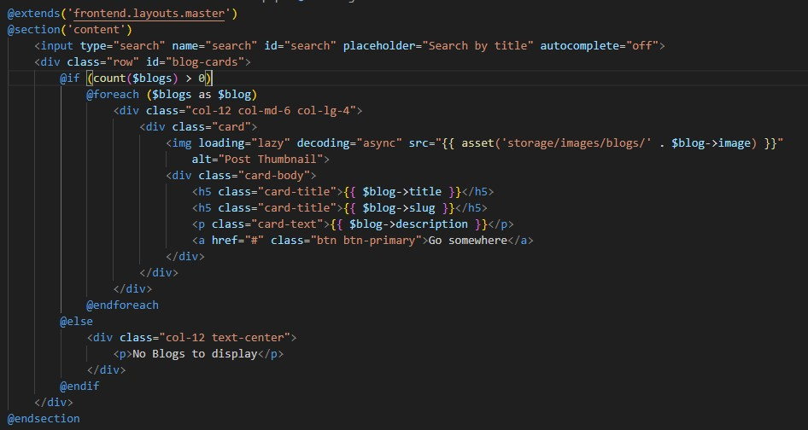

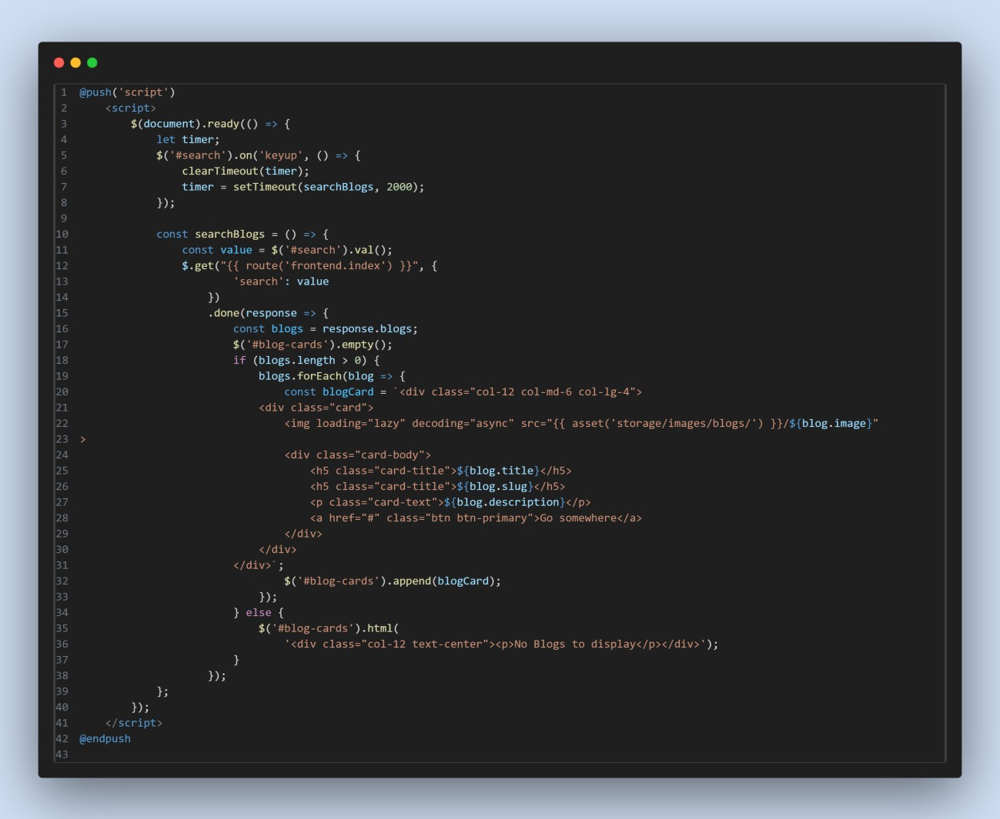

# **Authentication using Laravel UI Package:**

## 

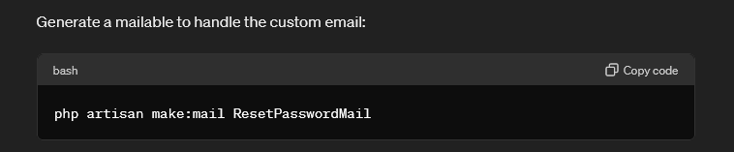



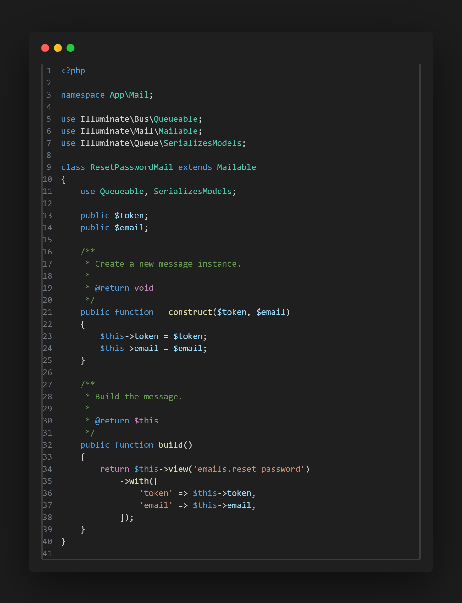

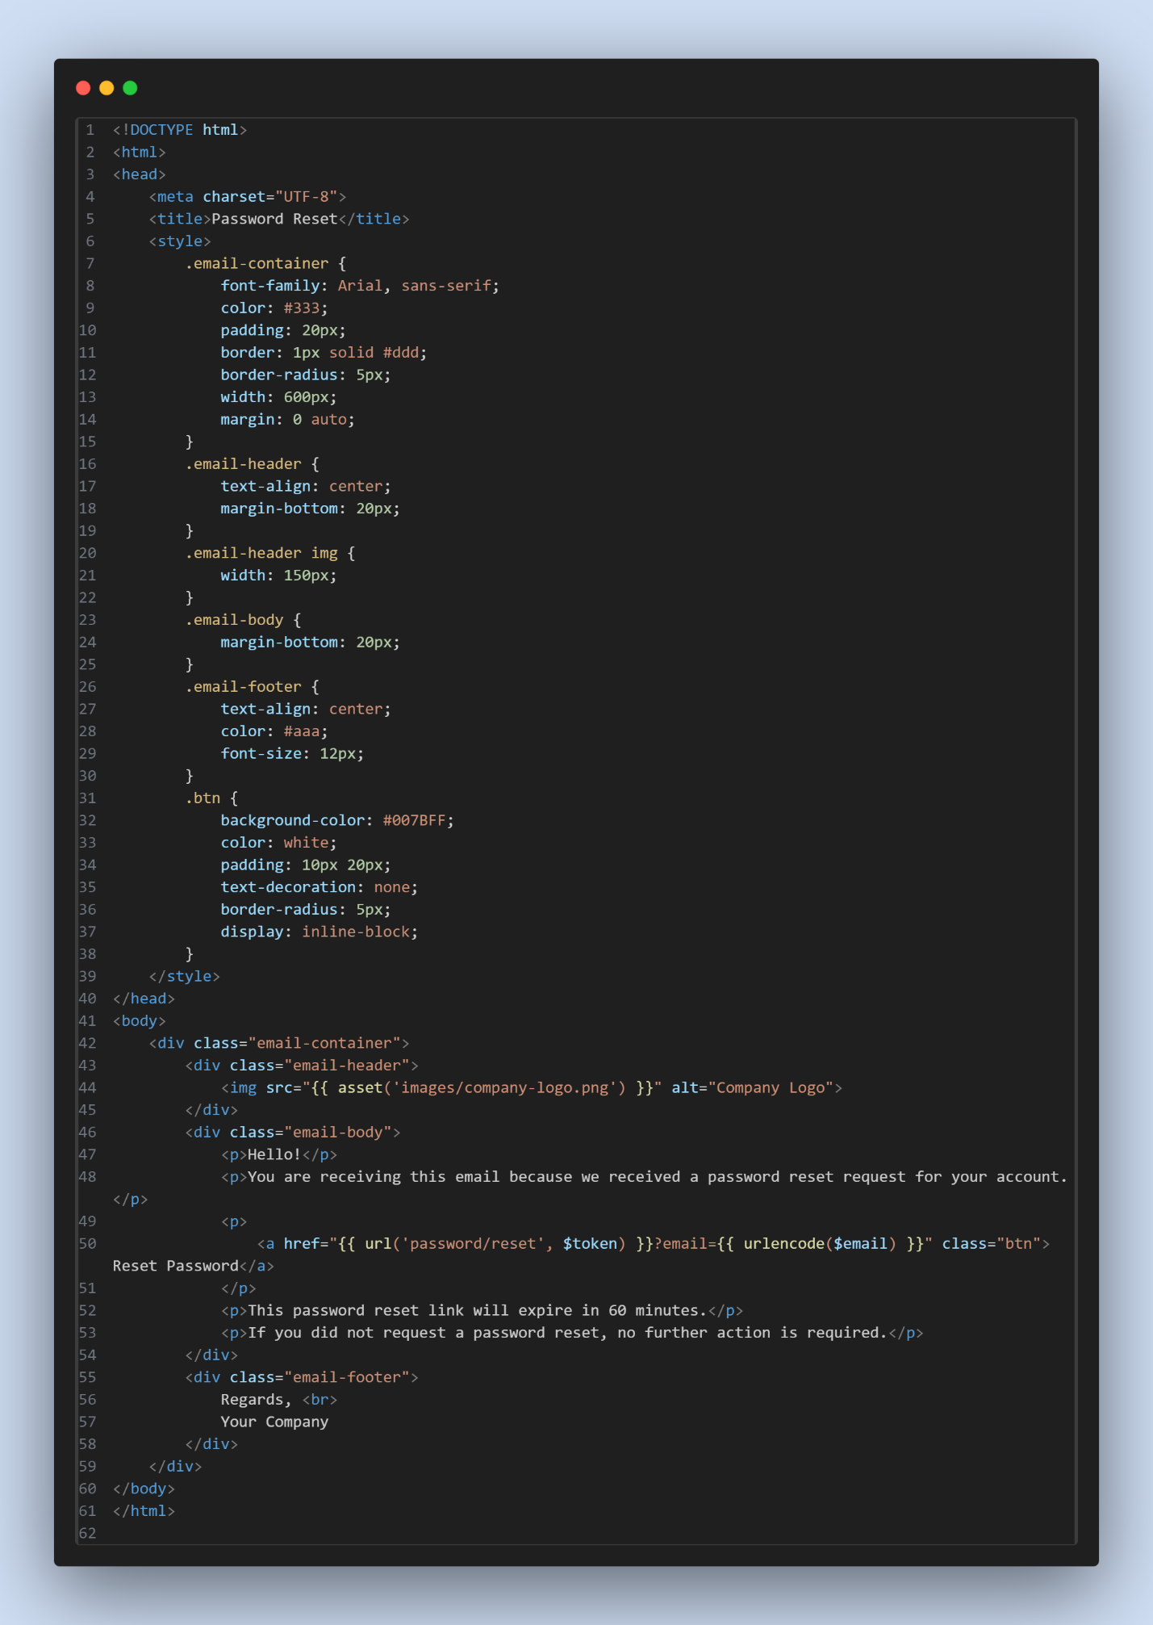

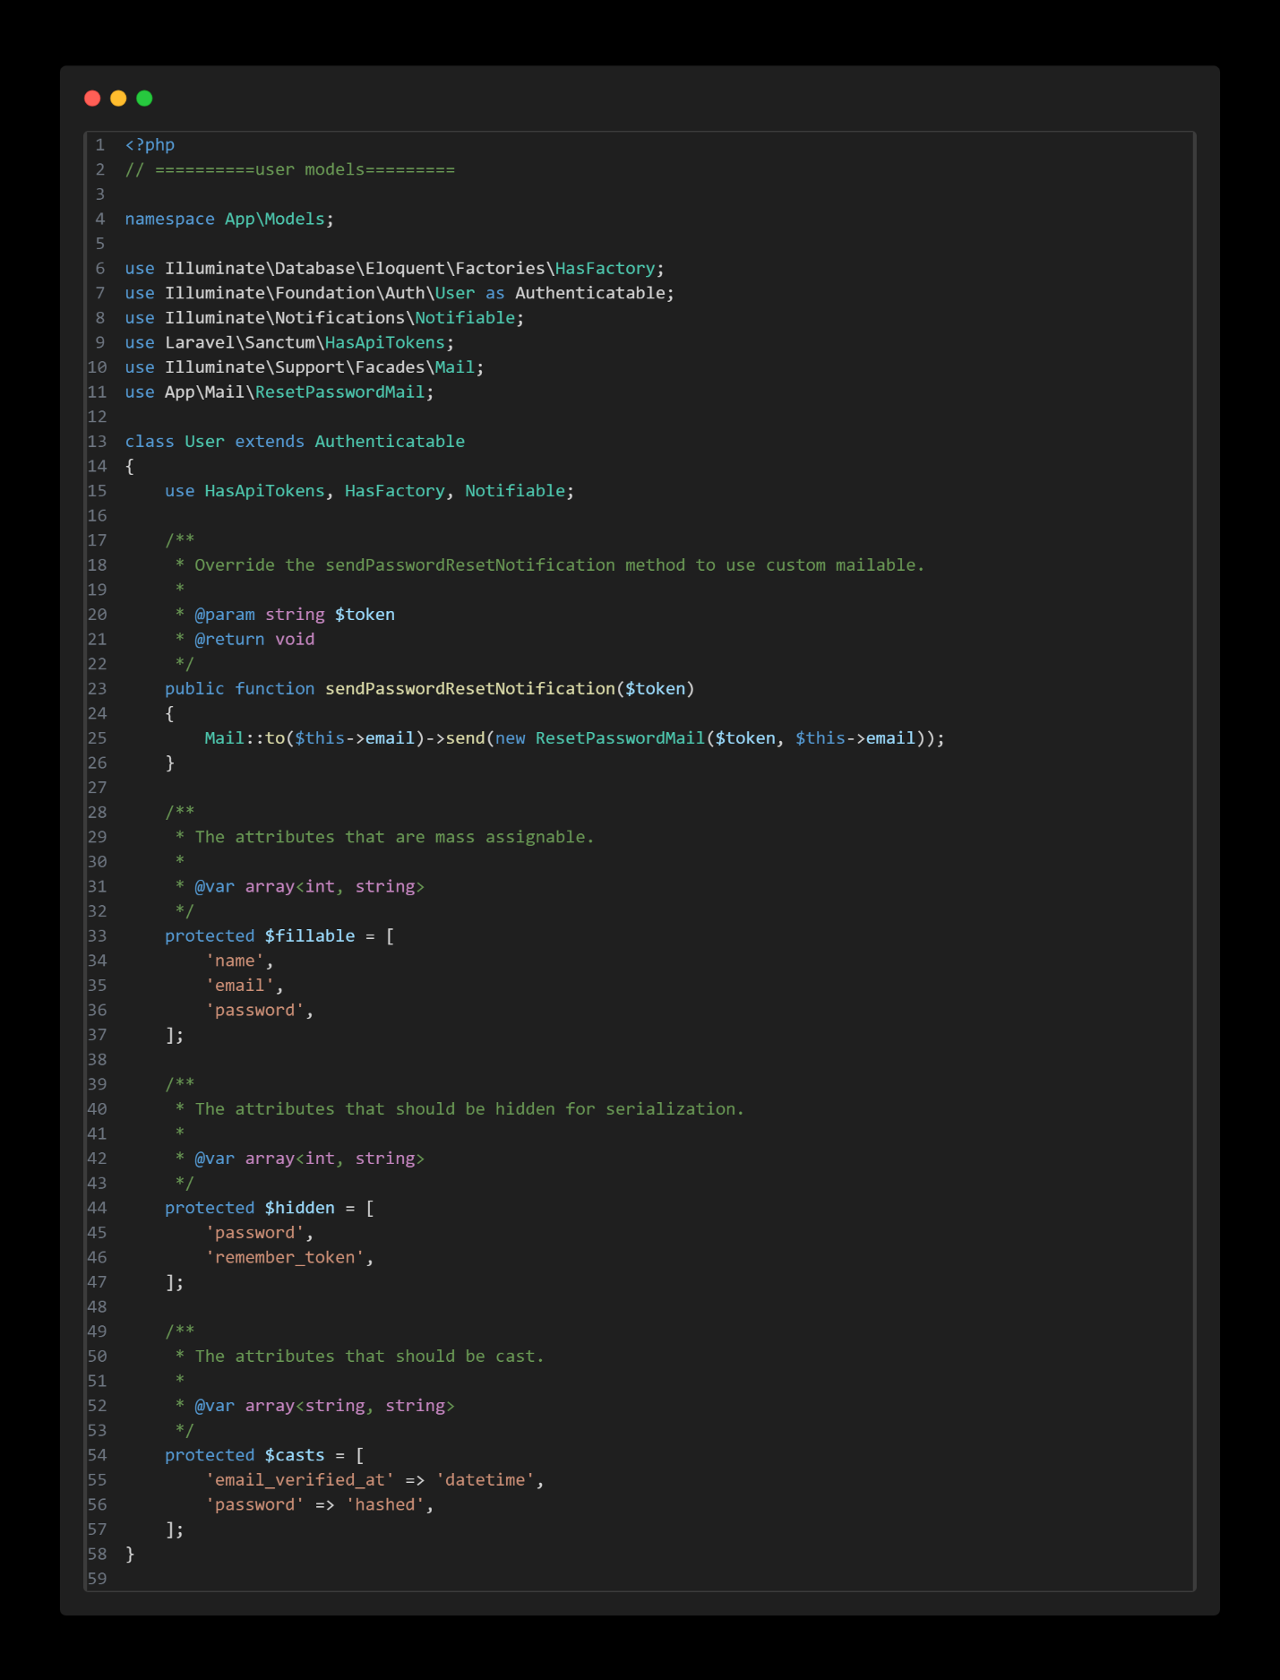

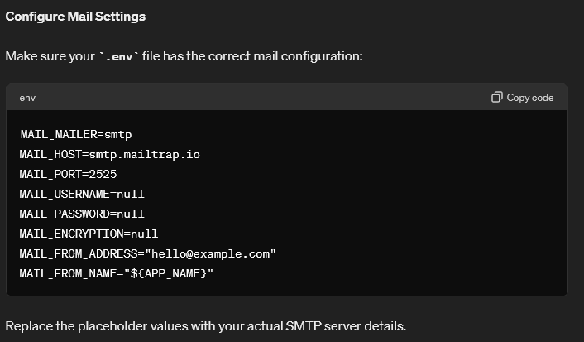

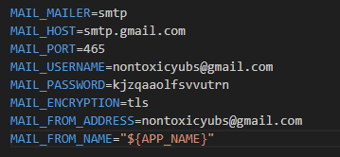

Get password from security<2-step-verification<App Passwords

# **Middleware:**

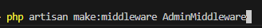

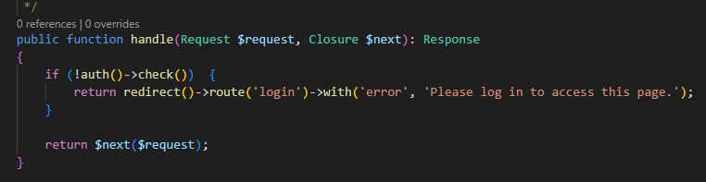

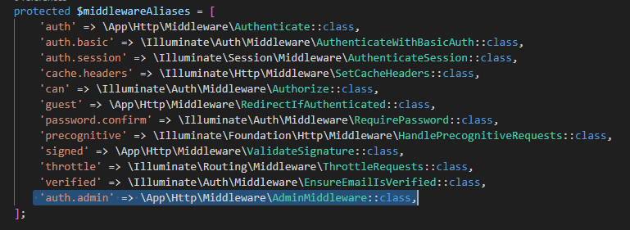

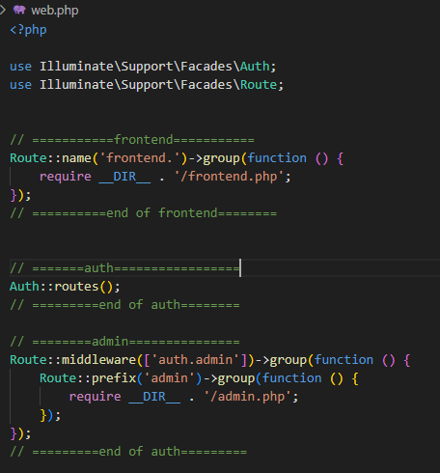

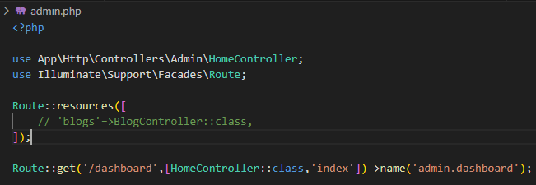

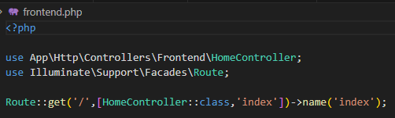

<https://amanj0314.medium.com/how-to-use-laravel-middleware-to-protect-your-application-1c76aa0acded>

# **Spatie user Roles & Permission management:**

<https://spatie.be/docs/laravel-permission/v6/installation-laravel>

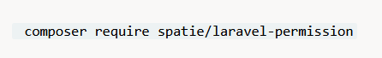

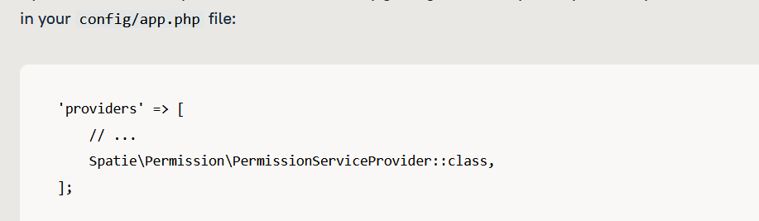

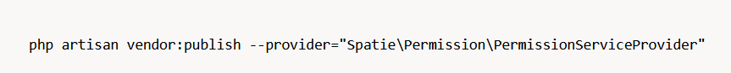

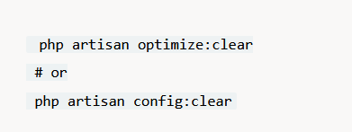

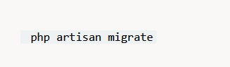

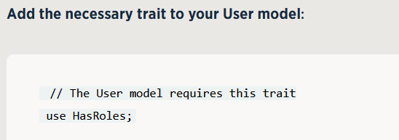

**Make Permission and Role Controller and do crud operation:**

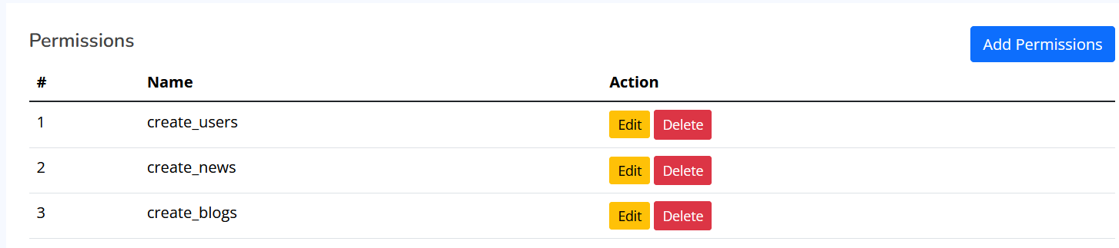

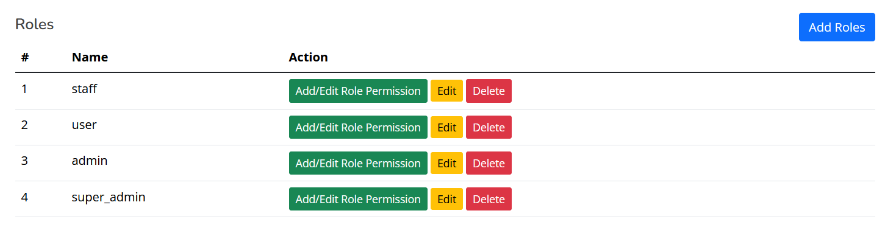

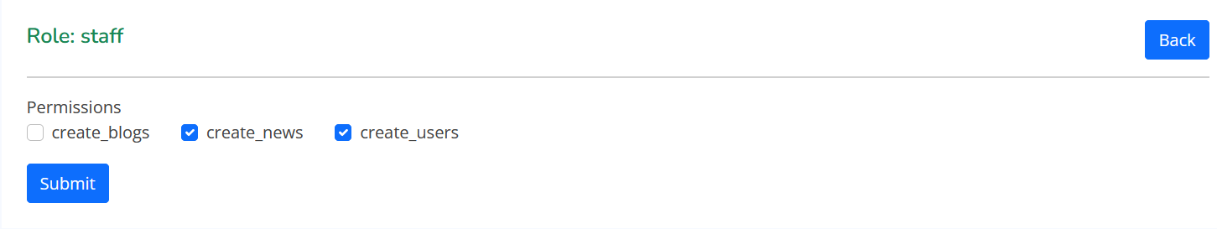

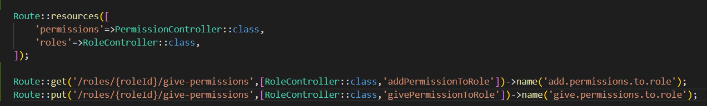

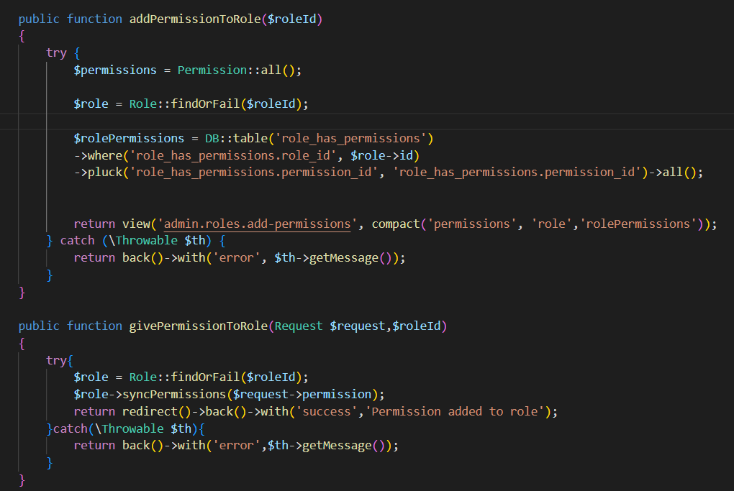

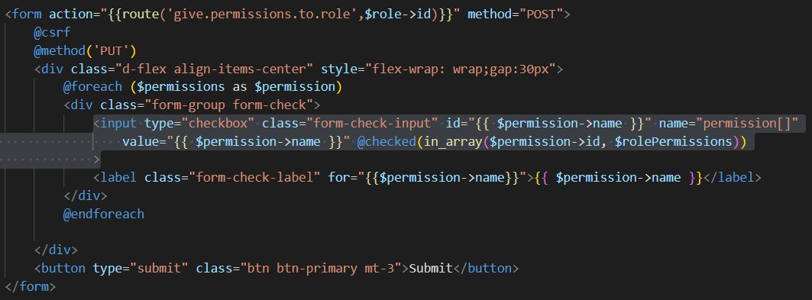

**Make user controller and perform crud operation:**

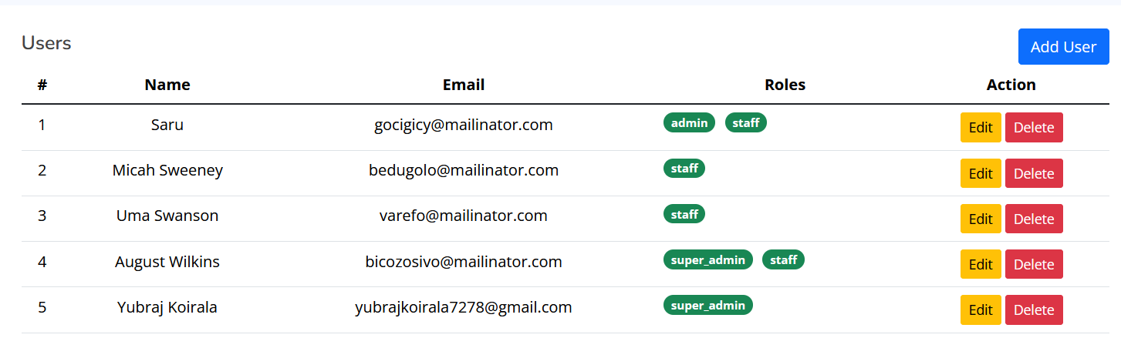

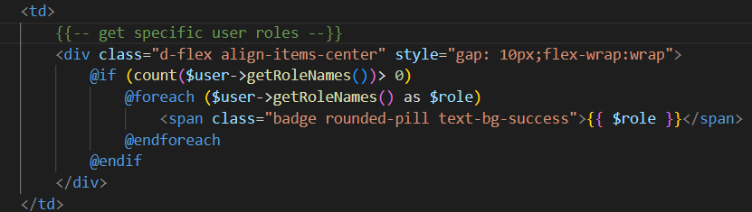

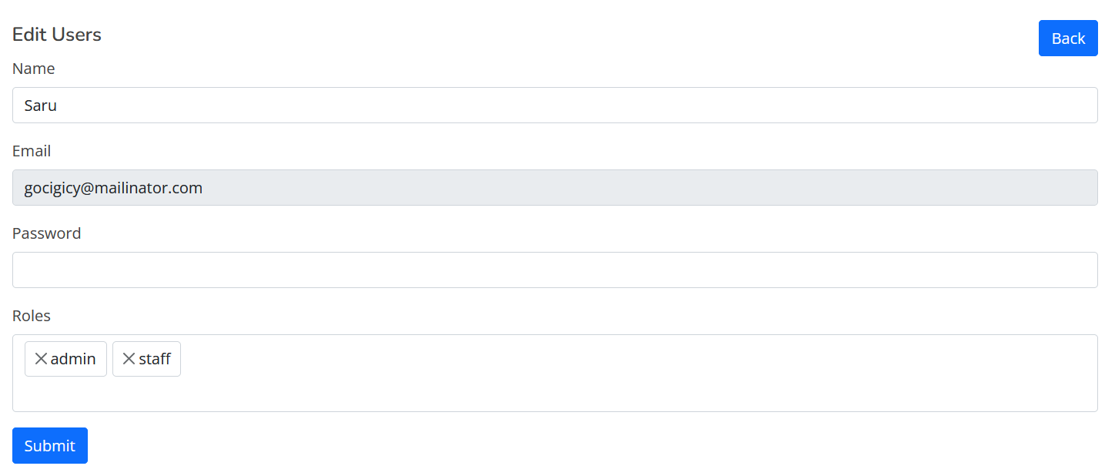

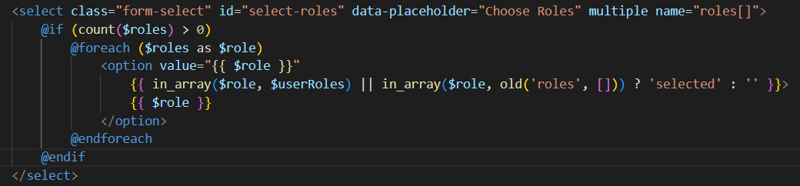

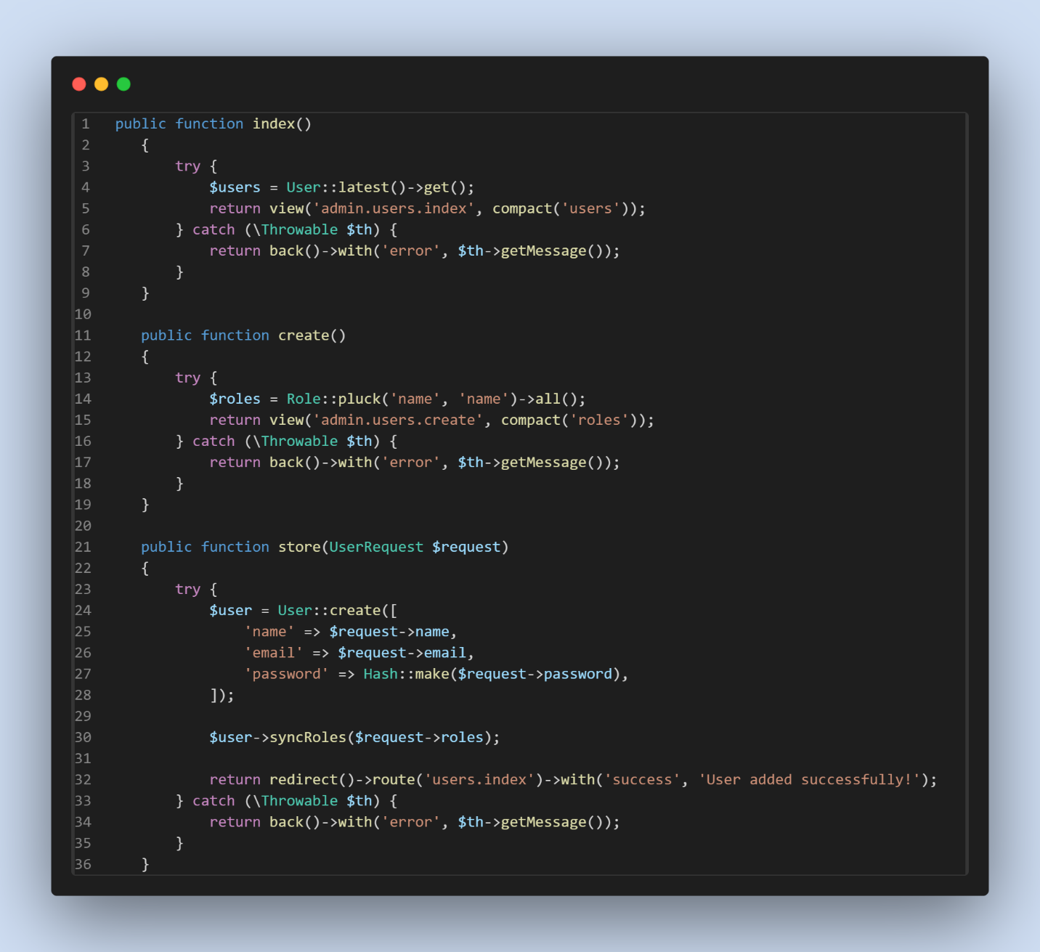

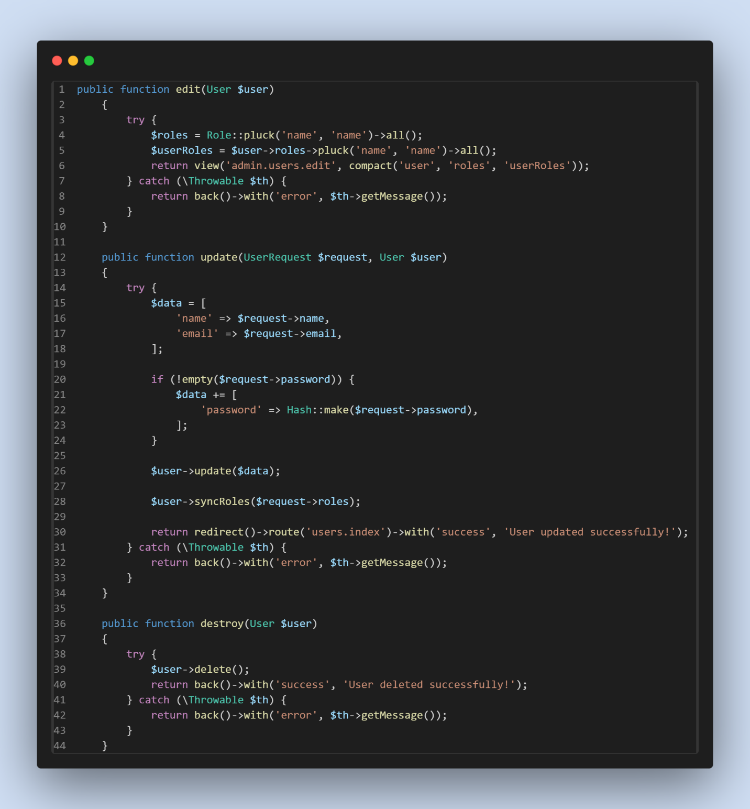

**Now, for roles and permissions:**

Step1:

<https://spatie.be/docs/laravel-permission/v6/basic-usage/middleware>



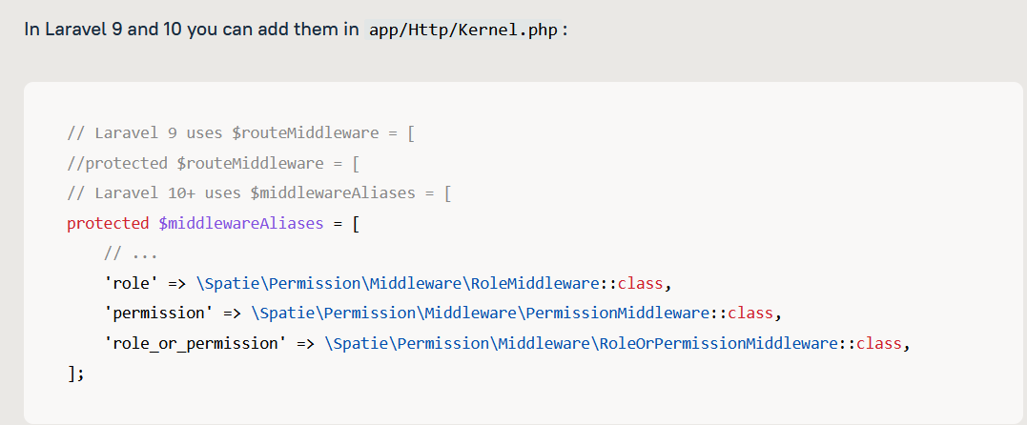

Step2:

In admin.php/web.php

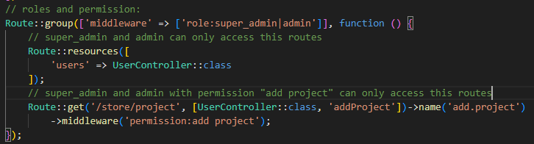

**Roles and permission in resource controller:** Step 1:

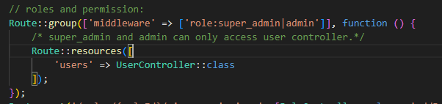

Step 2: (user controller)

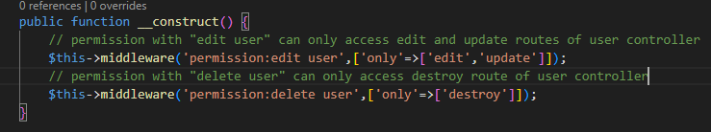

**Standard way to write the above roles and permission codes:**

Step 1: Kernel.php



Step 2: admin.php

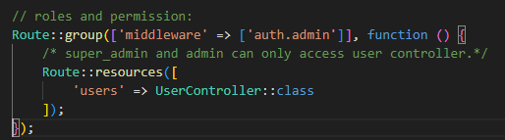

Step 3: AdminMiddleware.php

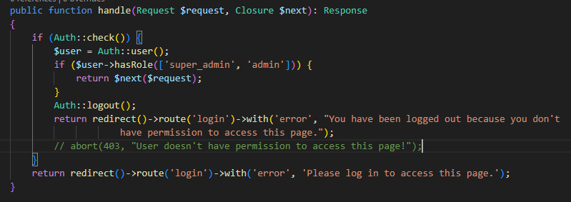

Step 4: Create RoleSeeder and AdminSeeder:

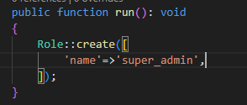

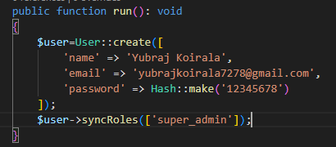

# **Laravel API CRUD:**

**Step:1**

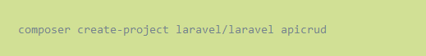

**Step:2**

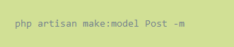

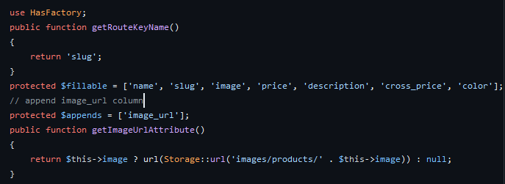

**Step 3:**

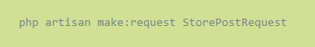

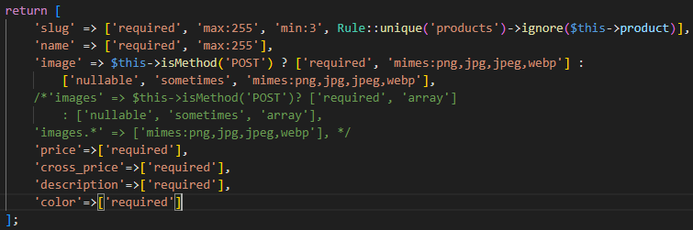

**Step 4:**

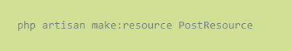

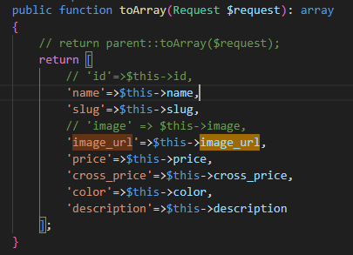

**Step 5:**

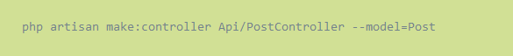

* **GET**

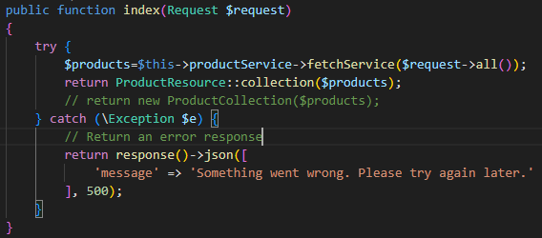

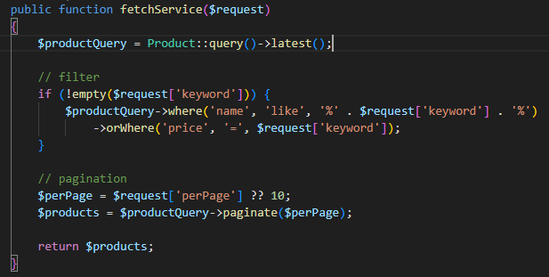

* **POST**

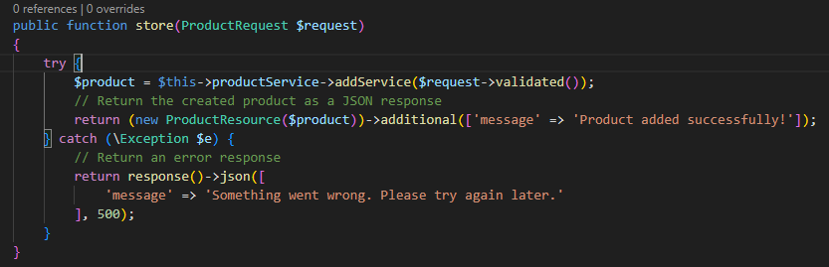

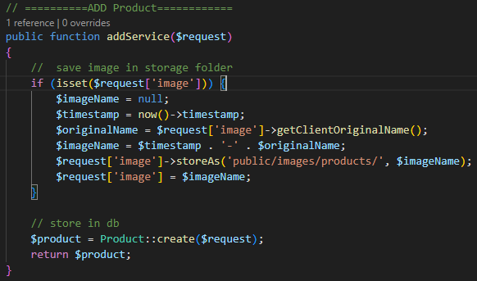

* **DELETE**

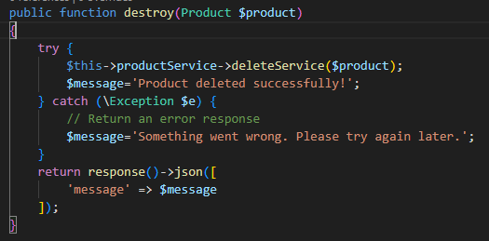

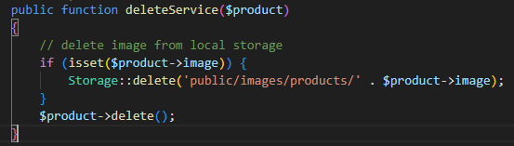

* **PUT/UPDATE**

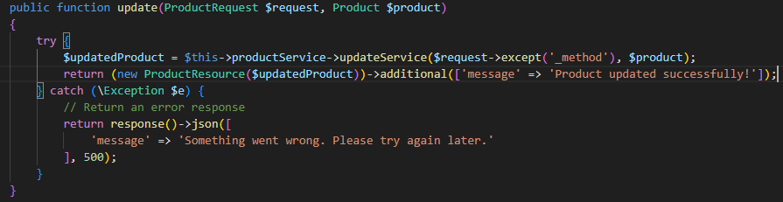

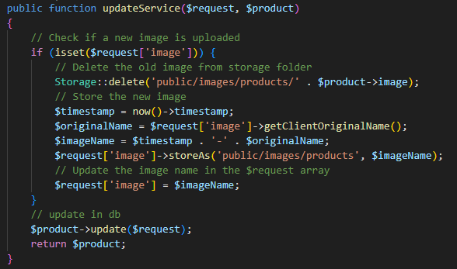

* **Get Single Product**

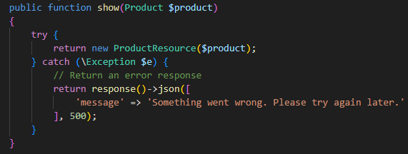

**Step 6:**

For Laravel 11 : php artisan install:api; php artisan route:cache; php artisan route:list

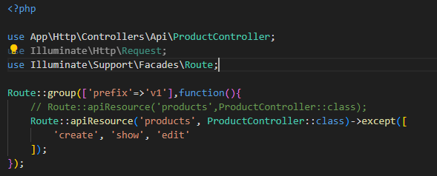

# **API Integration in VUE JS:**

**Step 1: (Project Setup References)**

<https://github.com/yubrajkoirala7278/laravel-vue-api-crud>

**Step 2: (.env.development)**

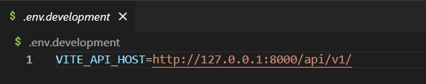

**Step 3: (service.js)**

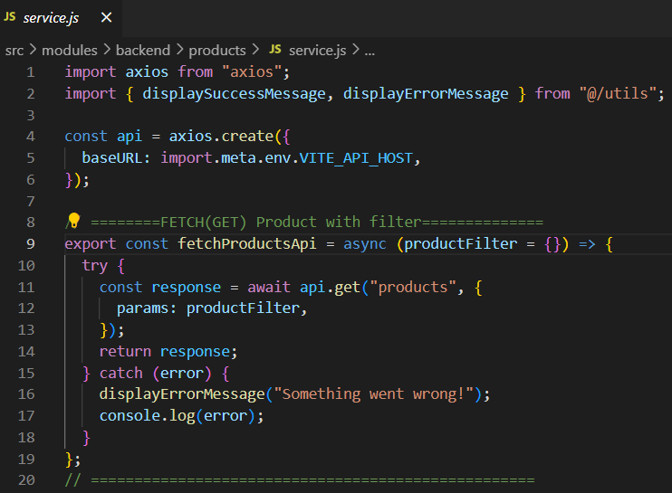

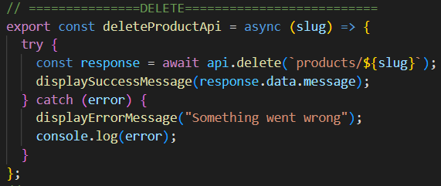

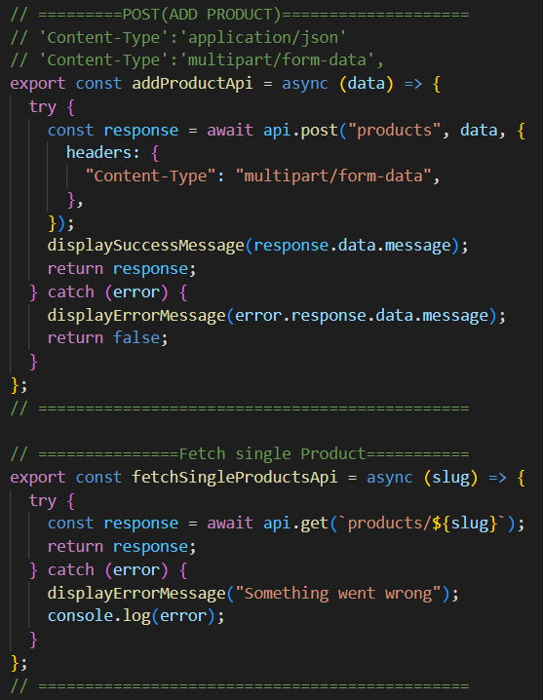

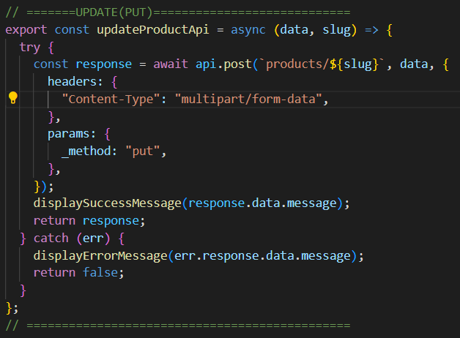

**Step 4: (store.js)**

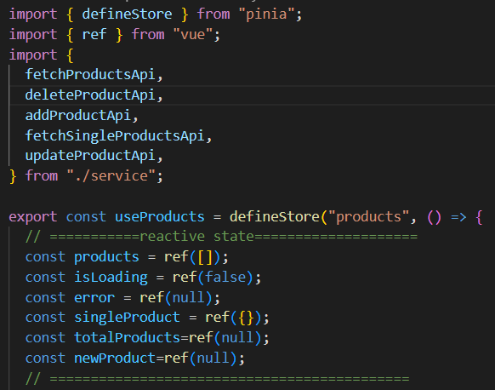

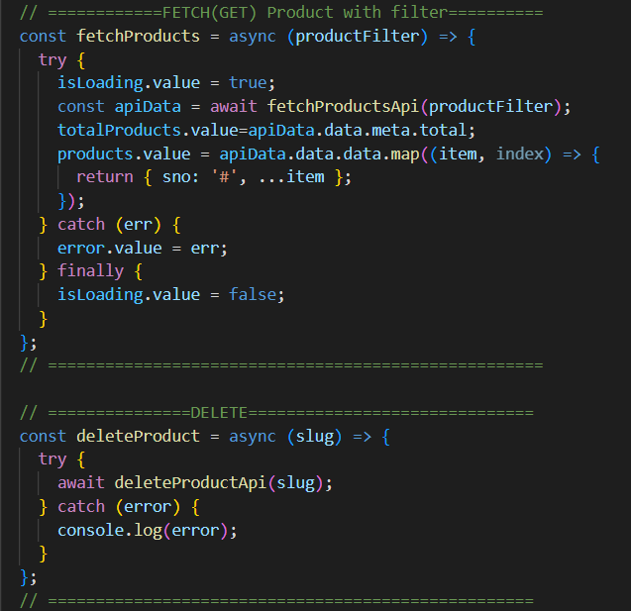

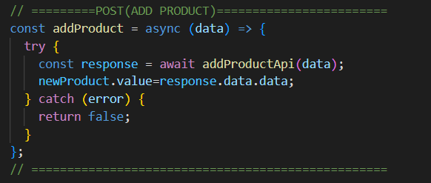

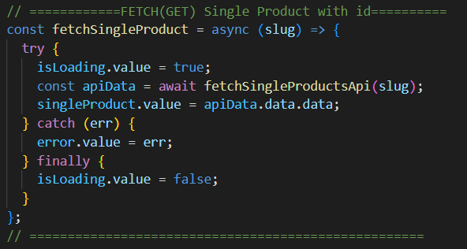

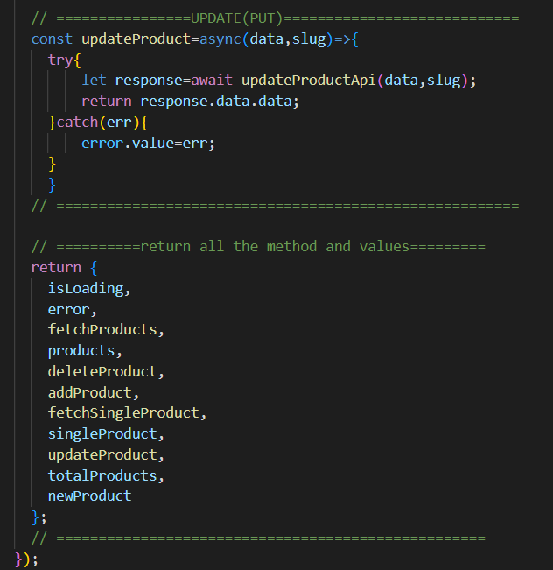

**Step 5: (utils.js)**

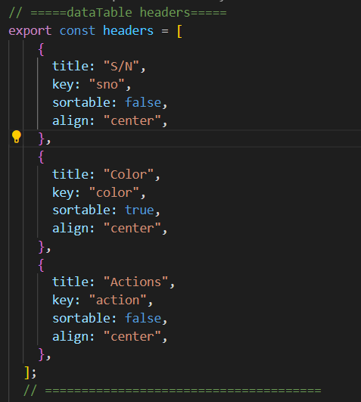

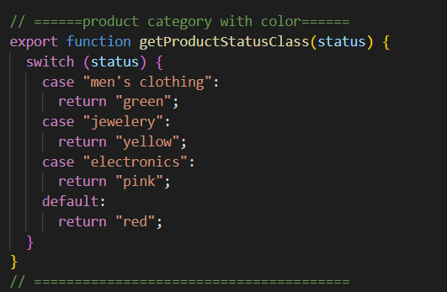

**Step 6: (product_view.vue)**

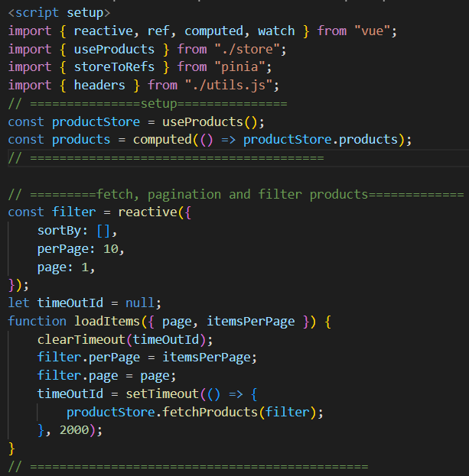

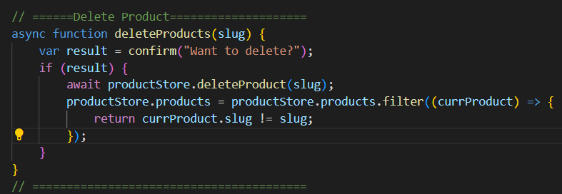

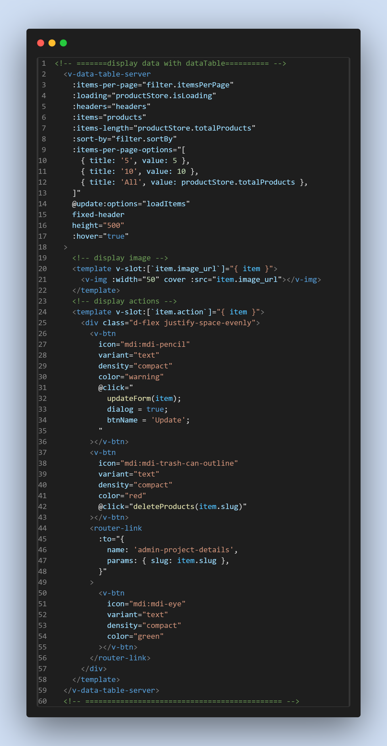

<!-- ==========Add/Update Product=================== -->

  <div class="text-start pa-4">

    <v-btn

      @click="

        resetForm();

        dialog = true;

        btnName = 'Submit';

      "

      color="green"

      class="text-capitalize"

    >

      Add Product

    </v-btn>

    <v-dialog v-model="dialog" width="auto" persistent scrollable>

      <v-card max-width="700" min-width="700" title="Add Product">

        <!-- form -->

        <v-form :valid="valid" @submit.prevent="submit" ref="productForm">

          <v-container>

            <v-row>

              <!-- name -->

              <v-col cols="12">

                <v-text-field

                  v-model="product.name"

                  :rules="[rules.required]"

                  label="Product Name"

                ></v-text-field>

              </v-col>

              <!-- slug -->

              <v-col cols="12">

                <v-text-field

                  v-model="product.slug"

                  :rules="[rules.required]"

                  label="Product Slug"

                ></v-text-field>

              </v-col>

              <!-- Image -->

              <v-col cols="12">

                <v-file-input

                  label="Product Image"

                  accept="image/png, image/jpeg, image/svg,image/jpg , image/gif"

                  prepend-icon=""

                  prepend-inner-icon="mdi-camera"

                  v-model="product.image"

                  show-size

                  counter

                  chips

                ></v-file-input>

              </v-col>

              <!-- price -->

              <v-col cols="12">

                <v-text-field

                  v-model="product.price"

                  :rules="[rules.price]"

                  label="Product Price"

                ></v-text-field>

              </v-col>

              <!-- cross price -->

              <v-col cols="12">

                <v-text-field

                  v-model="product.cross_price"

                  :rules="[rules.required]"

                  label="Product Cross Price"

                ></v-text-field>

              </v-col>

              <!-- Description -->

              <v-col cols="12">

                <v-textarea

                  v-model="product.description"

                  :rules="[rules.required]"

                  label="Product Description"

                ></v-textarea>

              </v-col>

              <!-- color -->

              <v-col cols="12">

                <v-text-field

                  v-model="product.color"

                  :rules="[rules.required]"

                  label="Product Color"

                ></v-text-field>

              </v-col>

            </v-row>

          </v-container>

          <v-card-actions>

            <v-spacer></v-spacer>

            <v-btn

              text="Cancel"

              @click="

                dialog = false;

                productForm.reset();

              "

              class="text-capitalize"

              variant="tonal"

              >Cancel</v-btn

            >

            <v-btn

              type="submit"

              :text="btnName"

              color="green"

              variant="flat"

              class="text-capitalize"

              :disabled="disableSubmitBtn"

              >Submit</v-btn

            >

          </v-card-actions>

        </v-form>

      </v-card>

    </v-dialog>

  </div>

  <!-- ========================================= -->

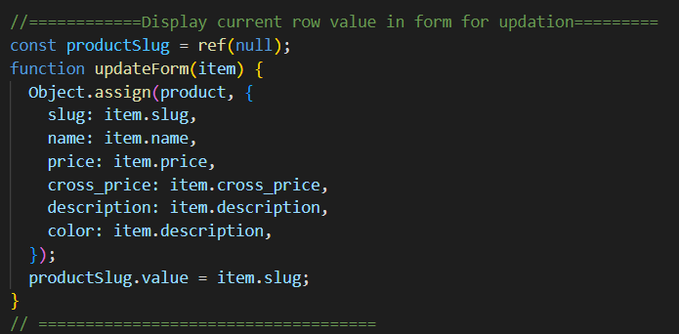

// =======Add Product======================

const disableSubmitBtn = ref(false);

const product = reactive({

  slug: null,

  name: null,

  image: null,

  price: null,

  cross_price: null,

  description: null,

  color: null,

});

// rules

const rules = {

  required: (v) => !!v || "Required",

  price: (v) => (!!v && v > 10) || "Amount must be greater than 10",

};

// generate automatic slug from name of product

watch(

  () => product.name,

  (newValue) => {

    product.slug = generateSlug(newValue);

  }

);

function generateSlug(text) {

  if (text != null) {

    return text.trim().toLowerCase().replace(/\s+/g, "-");

  }

  return null;

}

// submit form if validated

const productForm = ref(null);

const dialog = ref(false);

const btnName = ref("");

const { valid } = storeToRefs(productForm);

function submit() {

  productForm.value.validate().then(async ({ valid }) => {

    if (valid) {

      disableSubmitBtn.value = true;

      if (btnName.value == "Submit") {

        // ----------add product-----------

        let response = await productStore.addProduct(product);

        // append in frontend

        if (response != false) {

          products.value.unshift({ sno: "#", ...productStore.newProduct });

          dialog.value = false;

        }

      } else {

        // ----------update product-----------

        let response = await productStore.updateProduct(

          product,

          productSlug.value

        );

        // update in frontend

        if (response != false) {

          productStore.products = productStore.products.map((currProduct) => {

            if (currProduct.slug == productSlug.value) {

              return { sno: "#", ...response }; // Replace the object with updatedObject

            }

            return currProduct; // Keep the original object if it doesn't match the ID

          });

          dialog.value = false;

        }

      }

      disableSubmitBtn.value = false;

    }

  });

}

// reset form

const resetForm = () => {

  Object.assign(product, {

    slug: null,

    name: null,

    image: null,

    price: null,

    cross_price: null,

    description: null,

    color: null,

  });

};

// ========================================

**Step 7: (view single product)=>product_details.vue**

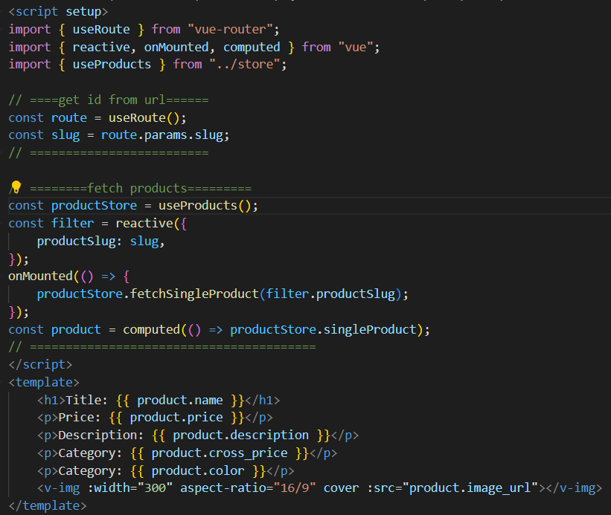

**Step 8: (router/index.js)**

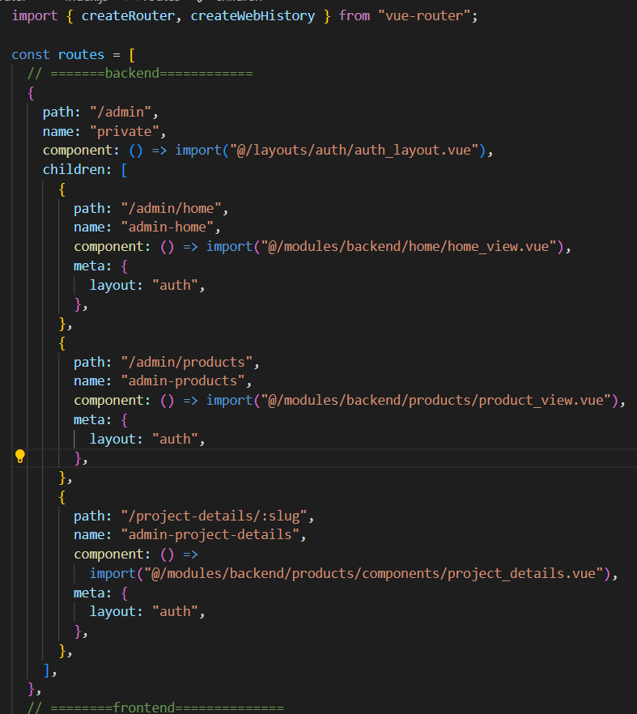

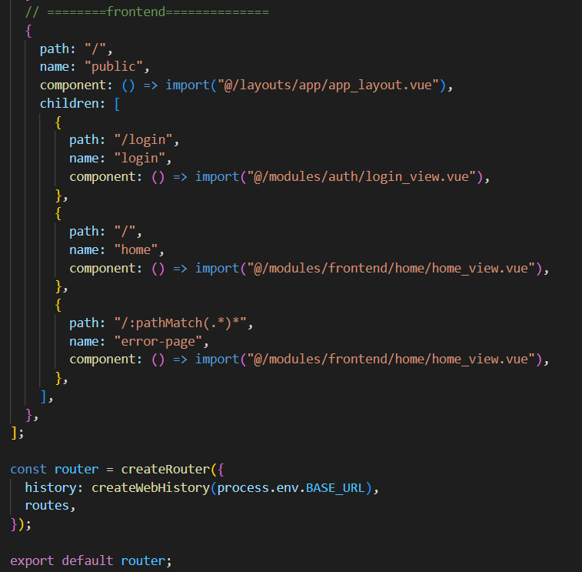

**Step 9: Data Table with no pagination**

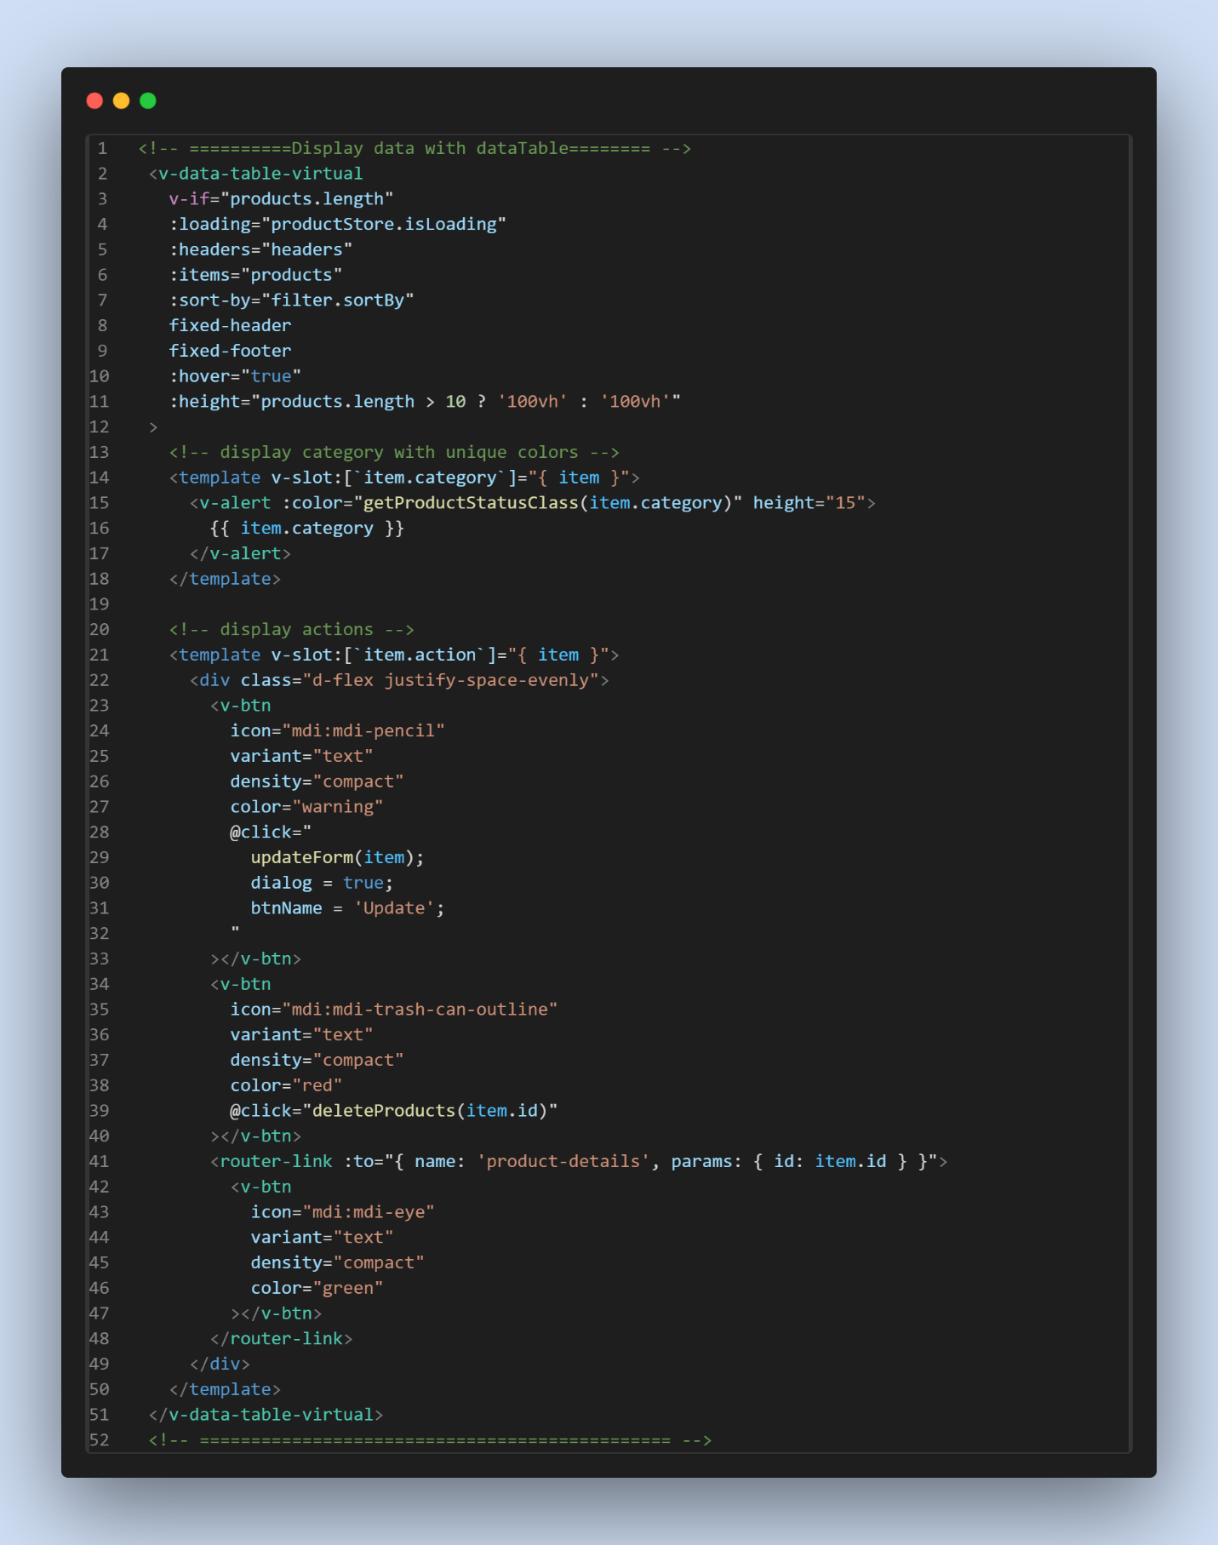

# **Authentication using Laravel UI Package:**

## 















Get password from security<2-step-verification<App Passwords

# **Middleware:**













<https://amanj0314.medium.com/how-to-use-laravel-middleware-to-protect-your-application-1c76aa0acded>

# **Spatie user Roles & Permission management:**

<https://spatie.be/docs/laravel-permission/v6/installation-laravel>













**Make Permission and Role Controller and do crud operation:**













**Make user controller and perform crud operation:**













**Now, for roles and permissions:**

Step1:

<https://spatie.be/docs/laravel-permission/v6/basic-usage/middleware>





Step2:

In admin.php/web.php



**Roles and permission in resource controller:** Step 1:



Step 2: (user controller)



**Standard way to write the above roles and permission codes:**

Step 1: Kernel.php



Step 2: admin.php



Step 3: AdminMiddleware.php



Step 4: Create RoleSeeder and AdminSeeder:



